Statistical Multiplexing Function
The description is valid for software version 2.11.0 and newer.
Since the 2.10.0 application Eazy Muxer enables statistical multiplexing in conjunction with Playout modules enabling the formation of MPTS streams with a fixed total bitrate. This is required in those cases when there is a strict limitation on the output bitrate, for example, when forming streams for transmission to multiplexes or satellite transponders.
Attention! If Eazy Muxer redundancy function is enabled, then when configuring the Statistical Multiplexing function you need to configure redundancy for Encoder Groups additionally.

Scheme
The image shows a scheme of functional component interaction in the Statistical Multiplexing mode.
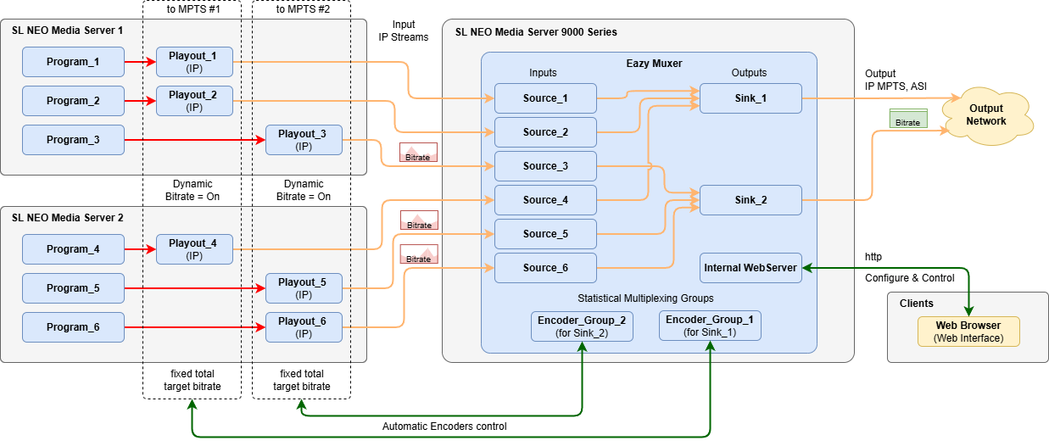

Configuration
The Statistical Multiplexing configuration consists of three steps.

Group Adding
To get started, add a new statistical multiplexing group to Encoder Groups menu: Eazy Muxer→Encoder Groups→New Group…. For each MPTS output stream with bitrate to be stabilised, a separate Encoder Group should be created.
Encoder Group creation window:
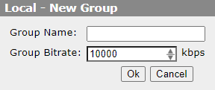
Parameter | Description
Group Name | An arbitrary name for the created group.
Group Bitrate | Total target bitrate of all streams in the group. Possible values are from 1000 to 50000 kbps.
Ok | Save changes.
Cancel | Close the window with no changes saved.

Add Encoder
Connect Playout modules to the created Encoder Group via the menu: Eazy Muxer→Encoder Groups→New Encoder…. A window will be opened with a list of previously configured groups. Select the target group to add a new encoder (Playout module in IP) to it.
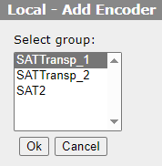
When you select the group, the Playout module connection settings window will be opened.
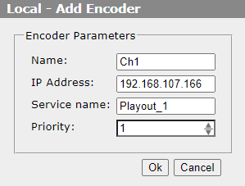
Parameter | Description
Name | An arbitrary encoder name that will be displayed in the Encoder Groups area.
IP Address | IP address of the Skylark server.
Service Name | The name of the Playout service specified in the server settings: Neovid→Administrator Control Panel→Manager→Video IO Boards→LAN Interfaces/Ethernet Adaptor→Playout→Name. Example: Playout_1.
Priority | Coders with lower value in Priority field get higher relative bandwidth (higher bitrate). Thus, it is possible to prioritise channels with dynamic content (e.g. sports) within the same Encoder Groups.

Encoder Configuration
For each Playout module connected to an Encoder Group, you are to enable dynamic bitrate control. To do this, activate the Dynamic Bitrate option in the Playout module settings: Administrator Control Panel→Manage→Video IO Boards→Lan Interfaces/Ethernet Adaptor→Playout_N→MPEG2 TS Parameters→Video→Dynamic Bitrate.
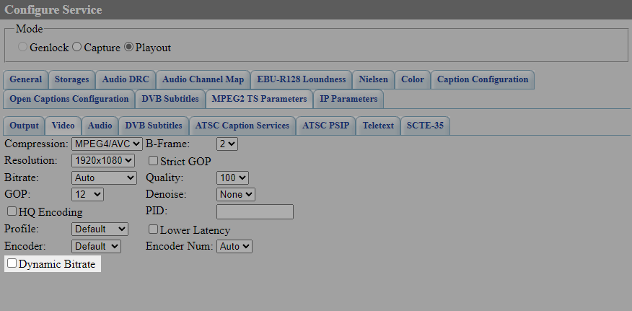

Launching
Run the configured Encoder Group to start dynamic bitrate control: Eazy Muxer→Encoder Groups→Start Group (Apply Changes)….

