Graphics List Function
The 2.7.0 version added a mechanism for controlling the output of graphics that allows you to:
- control the playback of graphics compositions from a single Graphics window in manual mode.
- load and edit graphic themes in playlist format in the playlist editor.
- when using the MOS Gateway module, get playlist events from NCRS.
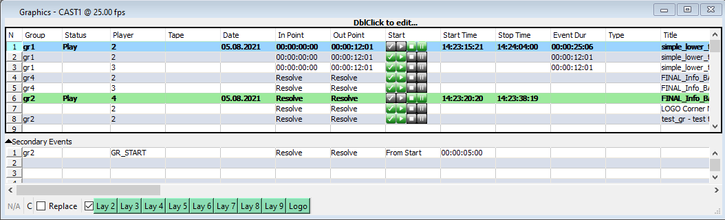

Configuring AirManager
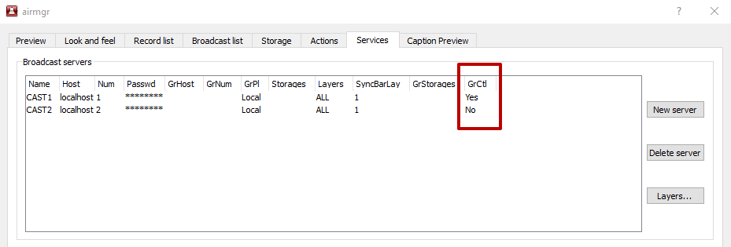
Activation of the Graphics List feature is done by toggling the AirManager→Menu File→Configure→Services→Broadcast servers→GrCtl option for the selected program channel:
- Yes - the function is enabled, access to the graphics control window: AirManager→Menu Window→Graphics→Channel Name,
- No - the function is disabled.

Graphics Management
After activating the Graphics List function, it is possible to use the Graphics window for the corresponding program channel. The Graphics window is visually similar to the Broadcast window which provides playlist management but initially it fulfills a different role and has a number of functional differences:
- allows playlists to be loaded, but they will be a list of clips rather than an executable playlist,
- each clip has individual control buttons Cue, Play, Stop, Freeze, which are placed in the Start column,
- for each clip, the Player column sets the number of the graphical playlist that will be used to play the clip. The playlist number is selected from the drop-down list. The numbering starts with 2, where 2 = CAST_LAY2,
- The Group column is used to group graphics events (e.g., events of the same design theme), allowing automated switching between them using the Start graphics group and Stop graphics group actions, as well as secondary events of the Graphics or Broadcast window.
The Graphics window supports autogeneration of secondary events allowing you to set up flexible custom graphics playout conditions.

Actions
The Graphics control list supports control using the action mechanism:
Executable | Parameters | Description
Start graphics group | - Param 1: Group name  - Param 2: Start delay in seconds (Example value: 0.3 - 300ms delay). Optional parameter. | The Start graphics group action fires the first event in the group
Stop graphics group | The action accepts one parameter:  - Param 1: Group name. The group name can be specified using a mask:  - * - replaces any number of characters,  - ? - replaces a single character,  - \ - escapes special characters,  - [] - matches one character in the specified group. | The Stop graphics group action stops all active events with the specified group.

Example
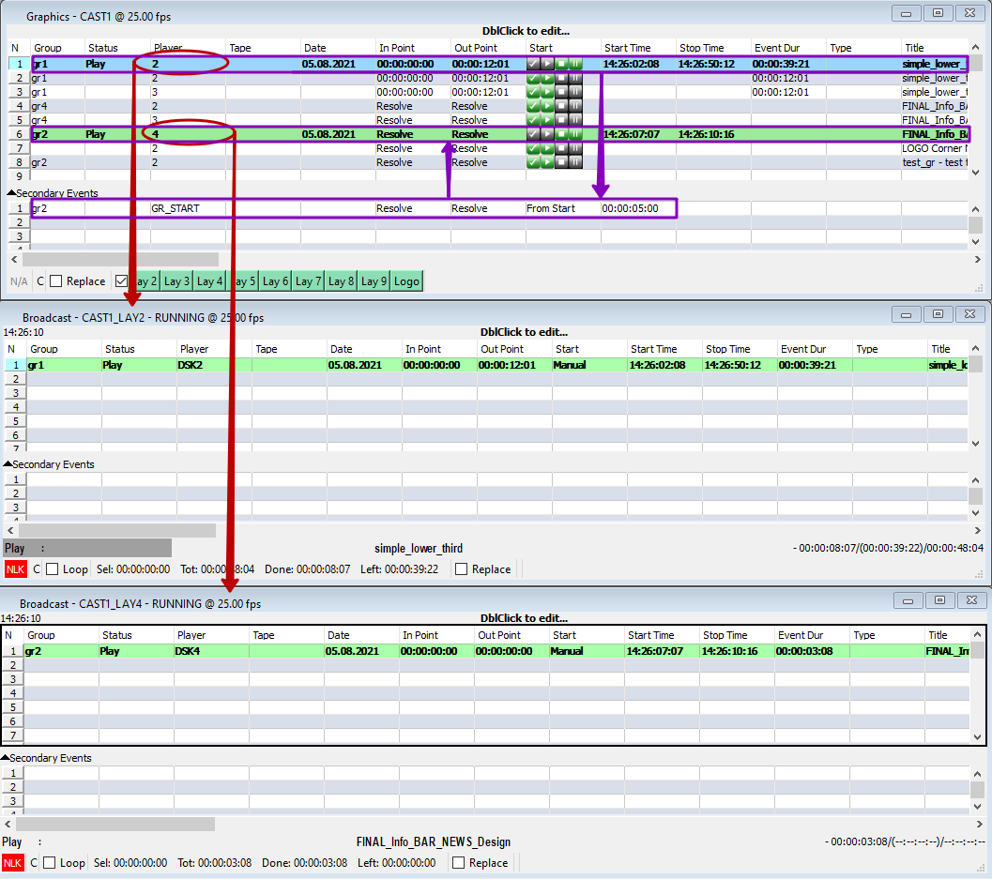
The screenshot is an example of graphics event distribution for the case when the simple_lower_third event from Graphics CAST1 line 1 is manually triggered. The Player column for this event is set to 2, so the simple_lower_third clip is sent to CAST1_LAY2 for playback.
Five seconds after playback starts, a secondary event configured for simple_lower_third is triggered, which triggers the first element of the gr2 group. This is possible because of a preconfigured program channel action that monitors the GR_START value in the Player column of the secondary event and executes a “Start graphics group” action with the group name gr2.
In turn, the system finds the first element with a group value equal to gr2 and then starts it for playback in the corresponding graphics layer (CAST1_LAY4, since Player=4).

