Image compression (squeezeback)
Squeezeback is the process of reducing the size of a video or image in order to display other elements on screen (such as logos, text, or graphics). Squeezeback can be used during the closing credits of a movie to show the viewer the announcement of the next movie or advertisement.


Creating a Graphic Composition

Length of a composition
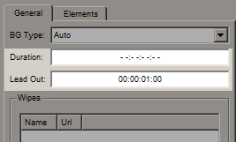
An infinite Duration: –:–:–:– is set for the composition, and the Lead Out parameter is set to 1 second, which is sufficient to correctly perform a finishing animation when the composition ends playback.

Graphic Elements
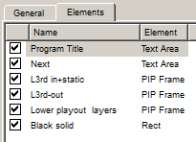
The composition consists of six elements in a given sequence (1 is the top element, 6 is the lowest element):
- Program Title (Text Area)
- Next (Text Area)
- L3rd in+static (PIP Frame)
- L3rd-out (PIP Frame)
- Lower playout layers (PIP Frame)
- Black solid (Rect)

Program Title
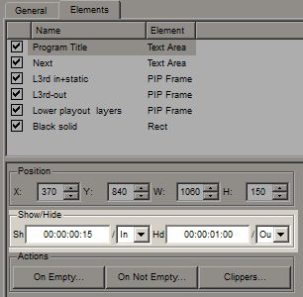
A Text Area element that displays basic text information. It is placed on top of all the layers of the graphical composition. This element is set to appear at 15 frames from the In point, to be hidden 1 second before the Out point.
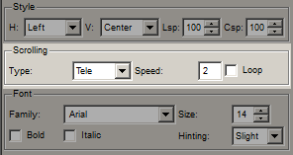
The animation of the text appearing from left to right is defined by the Tele effect of the Scrolling parameter.
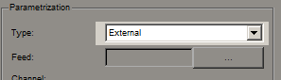
The parameterization type is set to External - parametrization from the playlist.

Next
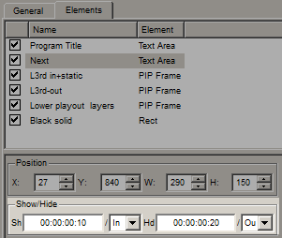
The Text Area element displays additional text information. This element is specified to appear on 10 frames from the In point, to be hidden 20 frames before the Out point. These values are chosen taking into account the time for the Fade-effects of appearing and hiding.
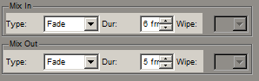
The smooth text appearance animation is defined by the Mix In Fade effect of 6 frames, and the hiding animation by the Mix Out Fade effect of 5 frames.

L3rd in+static
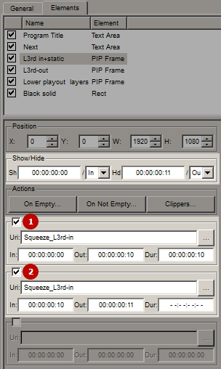
PIP Frame element, which loads the animated sequence Squeeze_L3rd-in imported into the media base. This element is set to appear at the In point, hiding 11 frames before the Out point.
Two Uri fields were used in the PIP:
- URI1 is used to show an animated Squeeze_L3rd-in appearance of 10 frames from 00:00:00:00 to 00:00:00:10.
- URI2 is used to show a static slice of Squeeze_L3rd-in of 1 frame duration from 00:00:00:00:10 to 00:00:00:11. This URI is set to infinite Dur: –:–:–:–, which will allow this element to be displayed on the screen for the entire duration of the graphic composition (the element will be hidden 11 frames before the Out point).

L3rd-out
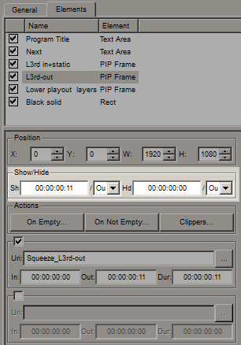
PIP Frame element that loads the animated output sequence Squeeze_L3rd-out imported into the media base. This element is set to appear 11 frames before the Out point, hiding at the Out point. This is the time selected to create a continuous glue with the static element of the L3rd in+static die, which was set to hide at 11 frames before the Out point.

Lower playout layers
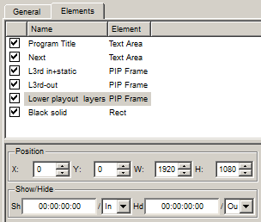
A PIP Frame element that uses the previous layers of the source frame on which this composition is superimposed as its content (we are talking about Program Channel layers). The element's display time is equal to the time the graphic composition is shown.
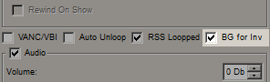
Parameter BG for Inv enables the translation mode of the previous layers in PIP.
The graphics_editor_animation vertical compression is set to four keyframes at the height of the L3rd in+static die.
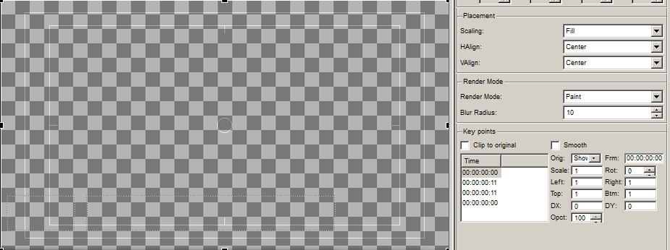
1 keyframe is the original state of the PIP at the 00:00:00:00 position from when the composition is shown (Orig = Show). The image inside the PIP is the original 1920×1080 size. This keyframe is needed to fix the object's parameters before starting the “compression” animation.
The 2 keyframe is the “compressed” state of the PIP at the 00:00:00:11 position from the show of the composition (Orig = Show). A trapezoidal distortion is applied to the PIP object with an upward shift of the lower edge of the Y-axis of 11 frames (set by the position of this keyframe), which frees up the screen area for the L3rd in+static slider to appear, “compressing” the PIP content.
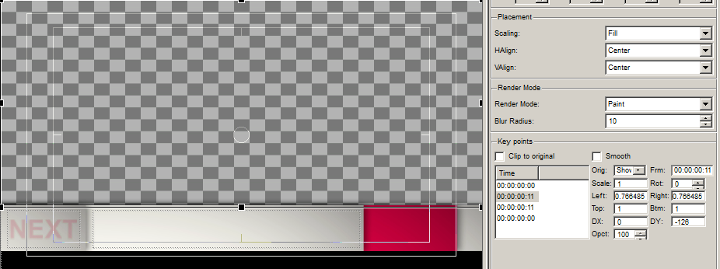
The 3 keyframe is the compressed state of the PIP at the 00:00:00:11 position from the hiding of the composition (Orig = Hide). This keyframe is needed to fix the object's parameters before starting the “uncompress” animation.
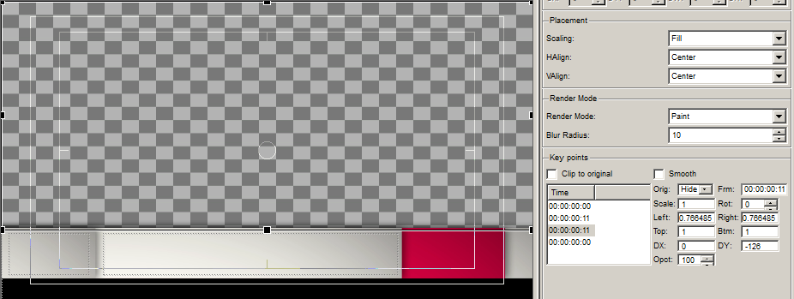
4 keyframe - brings the PIP dimensions to the original at the 00:00:00:00 position from when the composition is hidden (Orig = Hide). A trapezoidal distortion is applied to the PIP object with an 11-frame downward shift of the bottom edge of the Y-axis (set by keyframe position 3), which returns the PIP contents to their original size. At the same time, the “L3rd-out” pane is minimized to the bottom of the screen.
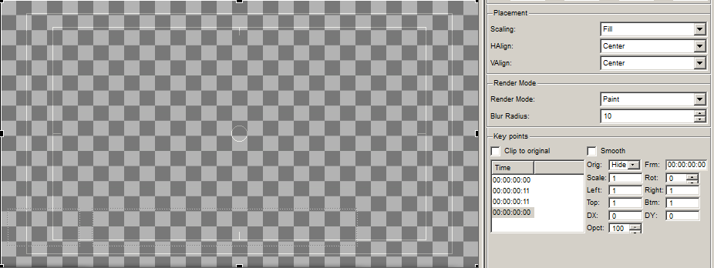

Black solid
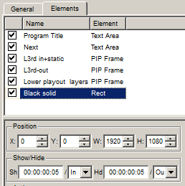
Since the L3rd in+static die has a transparent area between it and the bottom edge of the frame, a Rect element has been added to serve as a backing, covering this transparent area.

Putting the composition on the air

Download example
An example of the composition is available in the 2017 Media Base demo: Effects/Squeeze.

