Creating Circle Progress Bar
A circle progress bar allows visualizing the time left till the beginning of the next event - for instance, till the end of an ad block. The graphic composition will use the Video->Position Mapping function added in the version 2.0.183, which allows parametrizing the number of the displayed video frame by the Counter element value from the same composition.
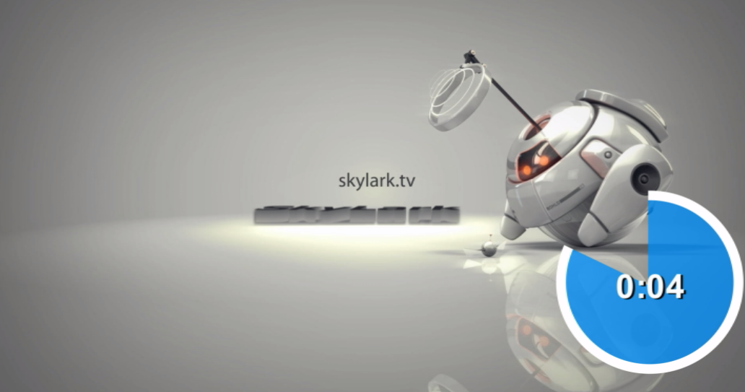

Creating Graphic Composition

Composition Duration
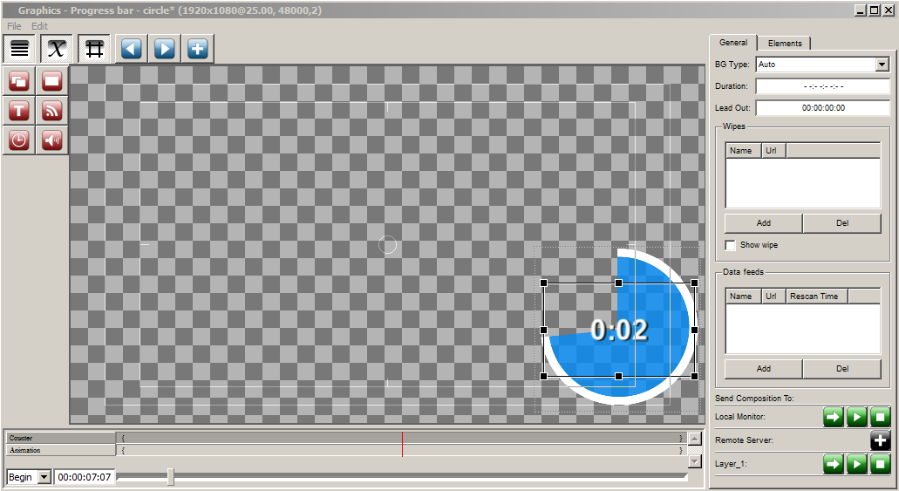
The composition has infinite Duration –:–:–:–.

Graphics Elements
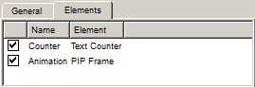
The composition comprises two elements in the set sequence:
- Counter (Text Counter)
- Animation (PIP Frame)

Counter
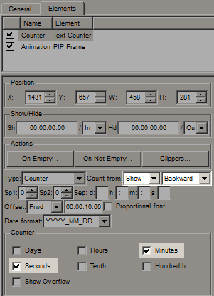
The Text Counter element countdowns time till the end of the composition. The element may be hidden, if displaying the digital counter on the screen is not required: for this, uncheck all boxes in the Counter section.
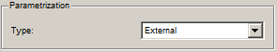
The element has the External type of parametrization from the playlist, which allows users to dynamically set the initial value for the countdown.

Animation
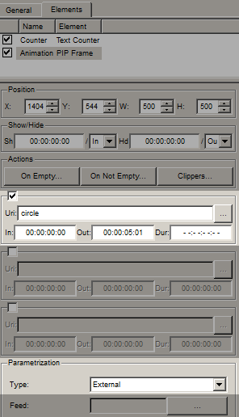
The PIP Frame element that displays the animated “circle” sequence previously imported to the media database.
The element has the External type of parametrization from the playlist, which allows users to dynamically set the Position Mapping values.
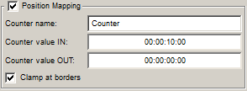
PIP Frame has the activated Position Mapping parameter, linking the number of the displayed “circle” frame to the Text Counter element value from this composition:
- Counter name - name of the bound counter.
- Counter value IN - the counter value in seconds, corresponding the IN point in the circle clip.
- Counter value OUT - the counter value in seconds, corresponding the OUT point in the circle clip.
We did not set the smooth appearing/disappearing animation. If needed, the appearance animation may be defined by the Mix In Fade parameter with the 5 frames duration, and the disappearance animation - by the Mix Out Fade effect with the 5 frames duration.

Saving
Save the graphic composition to the media database under the name Progress bar - circle: Graphic Editor→File→Save As….

Broadcasting Composition On-Air (Secondary Events)
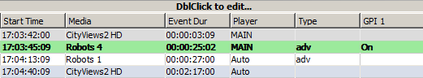
To automatically launch the progress bar during commercials, use free playlist columns:
- Type - is used for defining the commercials and calculating time till the end of an ad block. All commercial clips will have the adv value.
- GPI 1 - is used for specifying the necessity to launch the progress bar at the clip. Set the On value to show the progress bar.
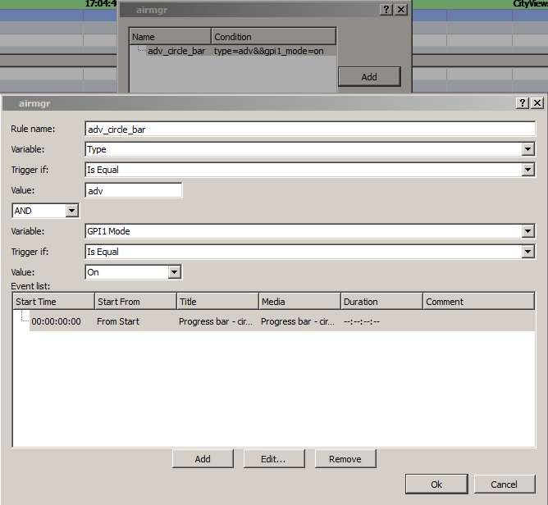
Configure a new rule for automatic generation of events by certain adv_circle_bar conditions: AirManager→Broadcast window→Right click→Secondary Event Generation Rules….
First set the triggering conditions: “IF Type=adv AND GPI1 Mode=On’’, launch the Event list tasks. Add a new task by clicking Add.
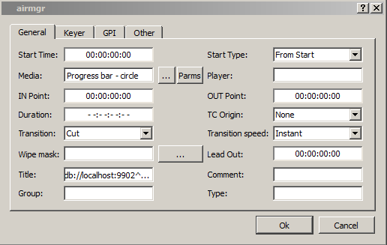
Select the previously saved graphic composition in the Media window. Press Params to move to parametrization settings of the composition.
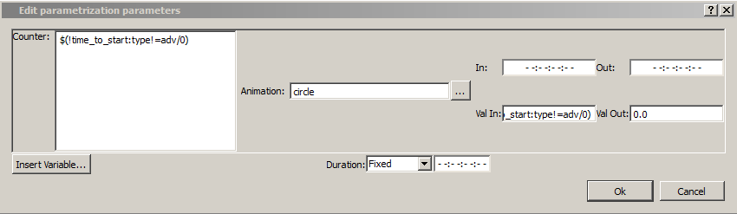
The original Counter and Val In values of the Animation element require a variable for calculating the time left till the end of an ad block.
Erase the Counter field value and press Insert Variable. Select the following values:
- Set the value to calculate for the next field
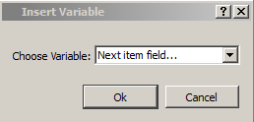
- Set the condition by which the Type NOT= adv field will be found. This allows to select the first clip after commercials, as it will not have the adv value in the Type field.
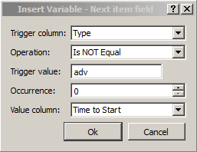
- Take the calculated Time to Start value that contains the time value (in seconds) till the beginning of a certain element defined earlier.
The value $(!time_to_start:type!=adv/0) will be inserted into the Counter field, copy it to the Val In field. Now these values will be calculated automatically in the moment of execution of Secondary Event rules.

Download example
The 2017 media database contains a composition example: Graphics/Counters/Progress bar - circle.

