Configuring Content Synchronization on Main and Backup Servers
Content synchronization on the main and backup servers is implemented in the mode of permanent unidirectional file copying: the main server works as usual, the backup server constantly synchronizes content of its own storage with the main storage content. Synchronization is implemented by the Transfer Manager app that must be configured at any server. Configuring is usually implemented at the backup server. However, there are no tough restrictions: selecting the server responsible for synchronization is implemented according to configurations of a certain system.
Transfer Manager work requires a license key. Check the activated key by the path: Transfer Manger→File→License Key.

Variant #1. Creating Rule for Content Synchronization: Соpy and Rotate
Work of Transfer Manager is based on rules. Create a rule to configure content synchronization on the main and backup servers by the New rule button at the right top part of the interface. Select the copying method in the open dialog box of the Transfer Mode field: Соpy and Rotate.
The Соpy and Rotate method is permanent automatic unidirectional synchronization of the ultimate (backup) storage relative to the initial (main) storage. The rule functioning scheme is the following:
- When new files (clips) appear on the initial storage, they are copied to the ultimate storage.
- When new versions of clips appear on the initial storage, they are replaced on the ultimate storage.
- Clips deleted from the ultimate storage are repeatedly copied from the initial storage.
- Deleting files from the initial storage doesn't instantly delete similar files from the ultimate storage.
- Only files that don't exist at the main storage are automatically enqueued and deleted on the ultimate storage. The deletion list is formed as far as the ultimate storage is filled. The deletion order is formed according to the time of the file last modification.
The Transfer Threads field allows you to define the number of simultaneously functioning file copying streams (maximum eight). Setting the value close to maximum may load the arrays and network, negatively affecting their workability. Conduct tests and check absence of artifacts (for example, brakes during playback).
The Reserve for Urgent Jobs field allows specifying the desirable number of backup streams. Transfer Manager can analyze executable playlists and enqueue for copying the files that are first for playback. When placing a new event to the playlist, all streams could be busy copying big files so copying files for the new event won't happen immediately. To avoid such situations, specify a few backup streams.
The Copy partial content item allows copying unfinished materials, in the process of record or import. Media Browser marks such materials as “PART”.
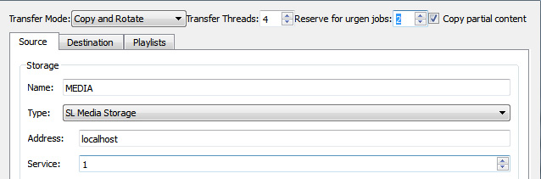

Source Tab
The Source tab contains information about the synchronization source - the main server, in our case. In the Name field, enter a random name for the source. In the Type field, specify the storage type for the main server - “SL Media Storage server database”. Enter the main server IP address into the Address field. In the Service field, select the server database number (1 by default).
User, Password - username and password used when Transfer Manager refers to the server database (if needed). If synchronization is required not for the whole database, but for one folder, select the folder-source by the button near the Subfolder field. The rest of parameters may stay unchanged.

Destination Tab
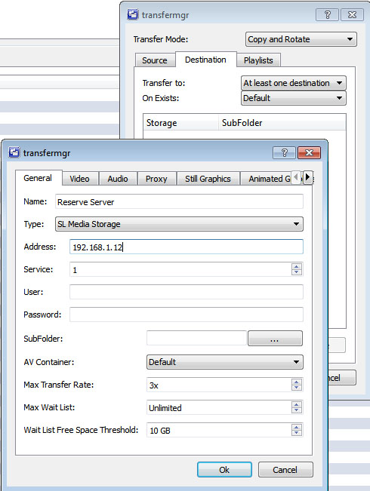
Move to the Destination tab. It contains information on parameters of the ultimate storage (backup server in our case) and file deletion rules.
Press Аdd at the bottom part of the opened window to open the field for information on the ultimate storage.
The Name, Type, Address, Service, User, Password, Subfolder parameters in this window are configured similarly to the initial storage.
AV Container - select the container for media-files (select Default=avi, when working with SL NEO server database).
Max Transfer Rate — select the maximum file copying speed, multiple to “real time”. Setting the value close to the maximum may load the arrays and network. Conduct tests and make sure that increasing the copying speed won't affect the work of playback and record channels.
Max Wait List — select the maximum length for the list of files for deletion. The Default value means that the list for deletion will grow and clips won't be deleted until the backup storage is almost completely filled (the default residual quota is “Wait List Space Threshold = 10 Gb”).
Wait List Space Threshold allows selecting the disk quota value in gigabytes: after reaching this quota, the server deletes clips from the Wait-list (if the “Max Wait List” value is set as “Default” or greater than zero).
Max Wait List Time is the time value, after which all clips in the Wait-list queue are automatically deleted.
Default values set in Max Wait List, Wait List Space Threshold and Max Wait List Time fields allow users to delay file deletion for the maximum time, while the backup array will always be almost completely filled. Setting parameters manually will hasten the deletion process: set the deletion list length to 50…300, expand the disk quota size in gigabytes and set the time interval, after which all Wait-list clips will be automatically deleted.

Playlists Tab
Transfer Manager can analyze executable playlists and enqueue for copying the files first in the queue for playback. Press Add in the PlayLists tab and enter the IP address and number of the playback service (Program Channel), for which we form the queue and copy the files. Several playout services can be specified, which is useful when there's only one database with materials, common for a few playout channels.
After entry of all necessary information and closing configuration windows, the created rule will appear in the Transfer Rules window list. The rule is launched by the Start rule button. Copying files will start in 40 seconds. Statuses of processes of copying and deleting files from the backup server are displayed in Transfer State, Transfer Jobs and Delete Jobs tabs.
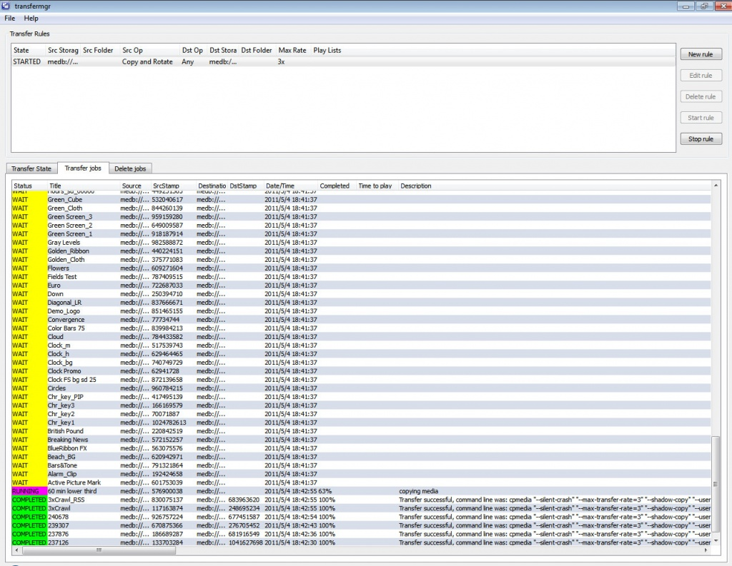

Variant #2. Content Synchronization Rule: Соpy for Playlist
The Copy for PlayList method is automatic unidirectional copying clips contained in the playlist from the initial (main) storage to the ultimate (backup) storage. In the PlayLists tab, press Add and enter IP addresses and sequence numbers of playout services (Program Channel), for which the files are copied.
The rule functioning scheme is the following:
- When new files (clips) appear at the initial storage, they are copied to the ultimate storage only when their names (“ID” - “Media” column) are present in the executable playlist.
- Deleting a clip line from the playlist will instantly delete corresponding files from the ultimate storage.

Processor Load
When configuring a lot of streams/rules for Transfer Manager, server processor load may get close to 100%, with a negative impact on recording and playback operations: freeze frames and drop frames will appear during broadcasting and recording respectively. To avoid this, monitor the CPU load and keep the 80-85 % level after changing Transfer Manager settings, especially after adding new streams and rules.

