Configuring GPI option (external USB module ONTRAK ADU208)
Let's look at configuring the server to receive external commands and control external devices via GPI via ADU208, which is a special case of working with GPI devices.
This function is optional and is not active in the standard set of server functions. It requires additional hardware and licensing to activate it.
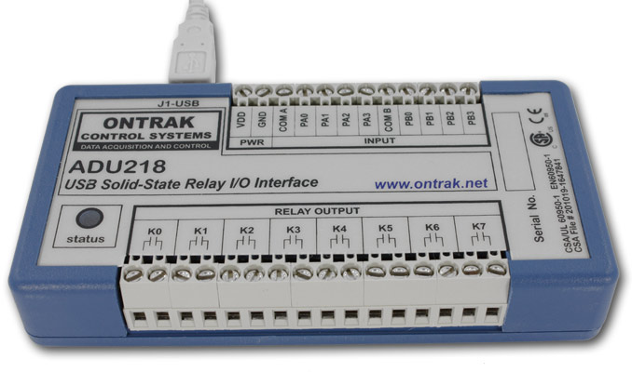
SL NEO servers work with external USB GPI modules manufactured by ONTRAK (ADU2XX series contains 8 inputs and eight relay outputs). The installation and configuration procedure is as follows:
- Connect the external GPI module to a free USB port of the server system unit. You do not need to install any drivers, once the initialization is complete, the Status LED on the USB module should change from red to green.
- Select Configure Server Components on the SL NEO Mediaserver icon in the tray (the server software must be pre-stopped with the Stop Server command). In the window of settings, from Available components field add to the right ONTRACK ADU 2×8 item.
- Launch server software (right click on SL NEO Mediaserver icon in tray).
Further settings will be performed from the Administrator Control Panel. The management console is accessed either locally from the server or from any machine in the network at http://ip_address:7901. You should log in as Administrator. After logging into the management console: in the left menu of the console, select Manage, then select the GPI Boards tab, in the GPI Board 1 window, select Service Enable. In the Enter Seral Number field, enter the serial number of the USB module (see the front panel of the module).
To save the settings, click the “Apply Changes” button at the top of the control console window.
You can check the functionality of the module in the Status item in the left menu of the control console. In the GPI Board_1 window select Action, in the opened window select Action - Set Pin, in the Param 1 field select the relay output number of the module (value 1 for K0 port) and in the Param 2 field select ON command. When you press OK, the relay of channel 1 (K0 on the module) will respond and close the contacts.
You can now create a rule (Action) for configuring a certain action.

Example 1: Setting up rules to control playback from external GPI commands
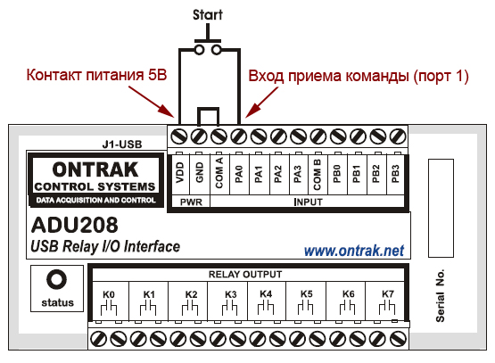
The GPI command receiver is triggered when the TTL level voltage is applied to the corresponding USB module input PA 0…3 or PB 0…3. In order to ensure triggering by a button with so-called “dry contacts”, it is necessary to make connections according to the diagram shown in the figure.
The configuration is done from the Control Panel: Administrator Control Panel→Manage→GPI Boards→GPIBoard_N.
In the GPI input actions field select Add Action. In the window that will open, specify the name of the rule in the Name field, select 1 (serial number of the control input port) in the Pin field, set the trigger in the Value field to ON and specify the server IP address in the Address field or leave the field blank if it means localhost.
The system of rules and commands (Action) of SL NEO media platform allows you to form a command in one server module and send it to another one. In the Service field on the button … select from the list the name of the server module, to which the command will be sent. In our example this is playback channel control service #1 (Program_1 in the list).
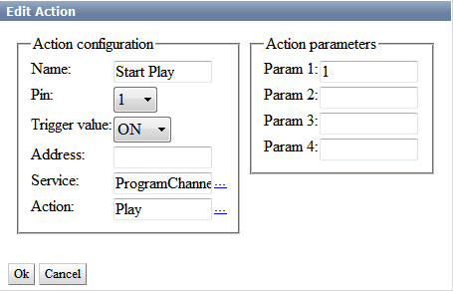
In the Action field on the button … select from the list the name of the command to be executed when issuing the external command (e.g., PLAY), specify the serial number of the layer to be controlled in the Action Parameters field (we specify 1 for the main full-screen playback layer and 2…8 for the graphics layers).
Hereinafter, you can create a new rule to stop the playback by the STOP command. Similar rules can be created for turning on/off the logo, moving to the next event in the playlist, etc.
To save the settings, click the “Apply Changes” button at the top of the control console window.

Example 2: Generating GPI commands at each playlist startup
Consider setting up a GPI command generation at each playlist startup, using General events, without linking to a specific playlist row.
The setting is done from the Control Panel: Administrator Control Panel→Manage→Program Outputs→Program_N→Actions→General events, where Program_N is the name of the program channel service for which the setting is made.
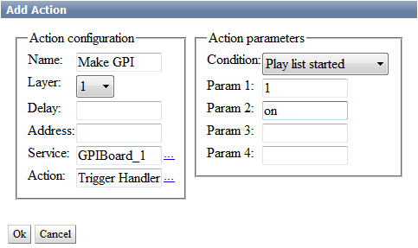
Unlike the Play list evernts tab, the General events tab sets general conditions when forming commands that are not tied to specific playlist lines.
In the General events tab, select Add Action. In the window that opens, specify the parameters of a new rule for generating the GPI command.
In the Action Configuration window specify the name of the rule in the Name field, select 1 (the primary full-screen layer of the playlist which controls the command generation) in the Layer field, specify the IP address of the server where the GPI device is physically present in the Address field or leave the field blank if localhost is set.
In the Delay field you can set the response delay in milliseconds. In the Service field, click the button. select from the list the name of the service to be controlled. In our example, this is the service that controls the GPI device (GPIBoard_1 in the list).
In the Action window select Trigger Handler - a trigger that will be triggered under a certain condition. In the Action parameters window in the Condition field, select Play List Started - the condition for triggering the trigger. In the Param 1 field indicate the pin number (of the GPI device physical output) and the position it should switch to: on/off (see a hint when you put the mouse cursor to an empty field).
Using similar scheme you can create a rule to generate GPI command when playlist is stopped.

Example 3: Generating GPI commands with linkage to individual on-air events
Let's consider setting up a GPI command generation using Play List events, with binding of the generated command to a specific playlist line.
The setting is done from the Control Panel: Administrator Control Panel→Manage→Program Outputs→Program_N→Actions→Playlist Events, where Program_N is the name of the program service for which the setting is made.
The rule will read the label from the specified column of the playlist row and generate the command for generating GPI commands. On the Playlist Events tab select Add action.
In the Action Configuration window specify in the Name field the name of a new rule, in the Layer field select 1 (the main full-screen layer of the playlist, which controls the command generation).
The Delay field specifies the delay (in milliseconds) from the start of the on-air event to the command generation. The same value of delay can be used when generating the GPI command before the end of the event and set the time interval from the GPI triggering to the end of the event.
In the Address field specify server IP address or leave the field empty if localhost is set. In the Service field click the button… select from the list the name of the service to be controlled. In our example, this is the service that controls the GPI device (GPIBoard_1 in the list).
In the Action condition window in the Vairable field specify the necessary column of the playlist where the marker will be located. For the example, let select GPI1 mode. We set the Trigger to EQUAL and specify in the Value field on - the rule will be executed, if the GPI1 field in the playlist string is set to on.
In order to make the GPI command appear at a certain time before the end of the broadcast event, select the “Trigger at end when primary matches” item. This item became available in SL NEO software versions 1.6.50 and higher.
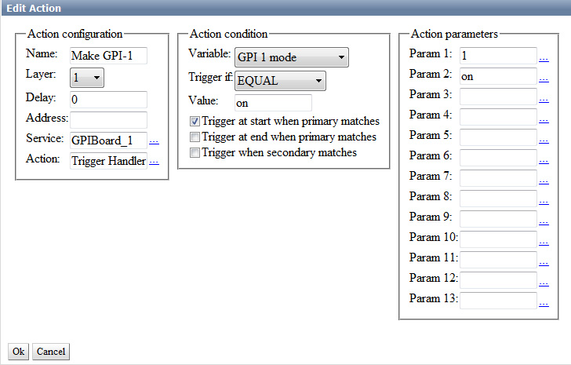
In the Action Parameters field in Param 1, specify the pin number (physical GPI device output) and the position it should switch to: on/off (see the hint when hovering the mouse cursor in an empty field).
To save your settings, click the “Apply Changes” button at the top of the control console window. In this case, the playback channel whose configuration was changed will be reloaded, playback on this channel will be paused at the moment of reloading.

