Squeezeback
Squeezeback is reducing video or image size to show other elements on the screen (e.g. logos, text or graphics). Squeezeback could be used during end credits, to show the audience a movie or commercial announcement.


Creating Graphic Composition

Composition Duration
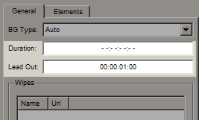
The composition has infinite Duration –:–:–:– and the Lead Out parameter equals 1 second, which is enough for a correct final animation while finishing the composition playback.

Graphics Elements
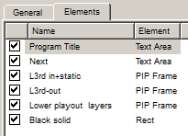
The composition comprises six elements in the set sequence (1 is the top element, 6 is the lowest one):
- Program Title (Text Area)
- Next (Text Area)
- L3rd in+static (PIP Frame)
- L3rd-out (PIP Frame)
- Lower playout layers (PIP Frame)
- Black solid (Rect)

Program Title
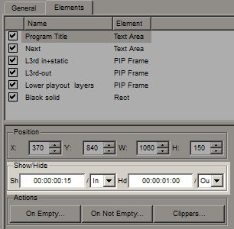
The Text Area element displays the basic text information and is placed above all layers of the graphic composition. This element has the set appearance value of 15 frames from the In point, and the disappearance value of 1 second before the Out point.
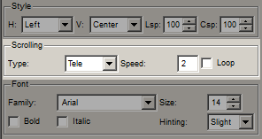
The animation of text appearing from left to right is defined by the Tele effect of the Scrolling parameter.
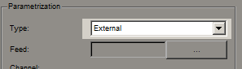
The element has the External type of parametrization - from a playlist.

Next
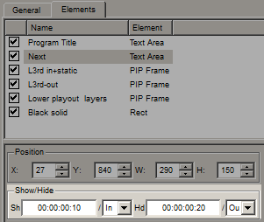
The Text Area element displays additional text information. This element has the set appearance value of 10 frames from the In point, and the disappearance value of 20 seconds before the Out point. These values are selected considering the time needed for Fade effects.
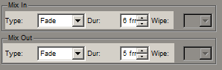
The animation of text smooth appearance is defined by the Mix In Fade parameter with the 6 frames duration, and the disappearance animation - by the Mix Out Fade effect with the 5 frames duration.

L3rd in+static
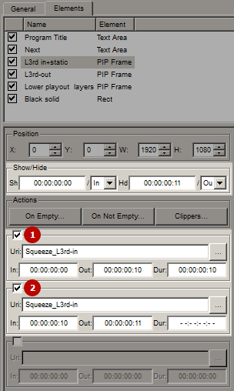
The PIP Frame element that loads the animated Squeeze_L3rd-in sequence imported to the media base. This element has the set appearance value in the In point, and the disappearance value of 11 seconds before the Out point.
PIP has two Uri fields activated:
- URI1 is used to display animated appearing of Squeeze_L3rd-in with 10 frames duration from 00:00:00:00 to 00:00:00:10.
- URI2 is used to display the Squeeze_L3rd-in static fragment with 1 frame duration from 00:00:00:10 to 00:00:00:11. This Uri has infinite Dur value of –:–:–:–, which allows this element to be displayed on the screen during the whole graphic composition (the element will disappear 11 frames before the Out point).

L3rd-out
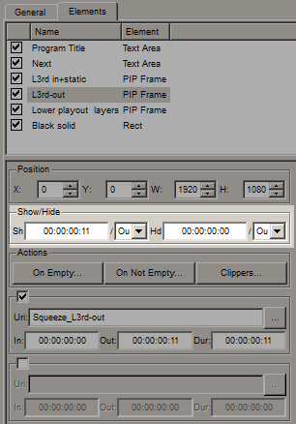
The PIP Frame that loads the Squeeze_L3rd-out animated exit sequence imported to the database. This element has the set appearance value of 11 seconds before the Out point and disappearance at the Out point. This time is selected to create continuous splicing with a L3rd in+static static lower third that has a disappearance value of 11 frames before the Out point.

Lower playout layers
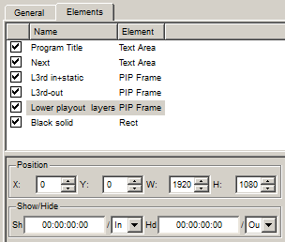
The PIP Frame element using previous layers of the original frame placed under the current composition, as its content (Program Channel layers). Time of displaying the element equals the time of showing the graphic composition.
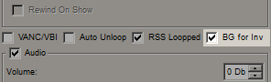
The BG for Inv parameter activates the mode of broadcasting previous layers in PIP.
This element has a set vertical squeezeback animation by four key frames, within the height of the L3rd in+static lower third.
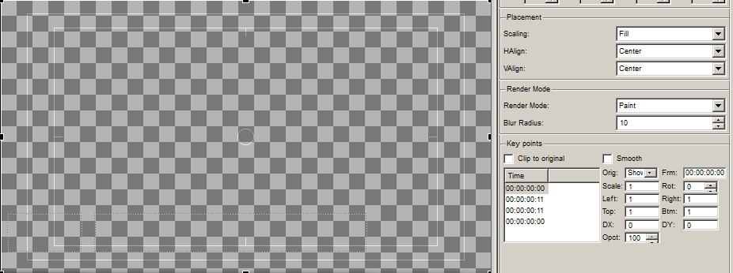
The first key frame is the initial PIP state in the 00:00:00:00 position from the moment of displaying the composition (Orig = Show). The image within PIP has the original 1920:1080 size. This key frame is necessary for fixing the object parameters before the squeezeback animation starts.
The second key frame is the squeezed PIP state in the ‘'00:00:00:11 position from the moment of displaying the composition (Orig = Show). The PIP object is under a trapezium distortion with a 11 frames shift of the lower edge up the Y axe (is set by the key frame position), which frees space on the screen for appearance of the L3rd in+static lower third, squeezing the PIP content. The third frame is the squeezed PIP state in the 00:00:00:11 position from the moment of the composition disappearing (Orig = Hide). This key frame is necessary for fixing the object parameters before the “unsqueezing” animation starts. The fourth frame returns PIP to the initial size in the ‘'00:00:00:00 position from the moment of composition disappearing (Orig = Hide). The PIP object is under a trapezium distortion with a 11 frames shift of the lower edge down the Y axe (is set by the third key frame position), which returns initial size to the PIP content. At the same time, the L3rd-out lower third minimizes to the screen bottom.
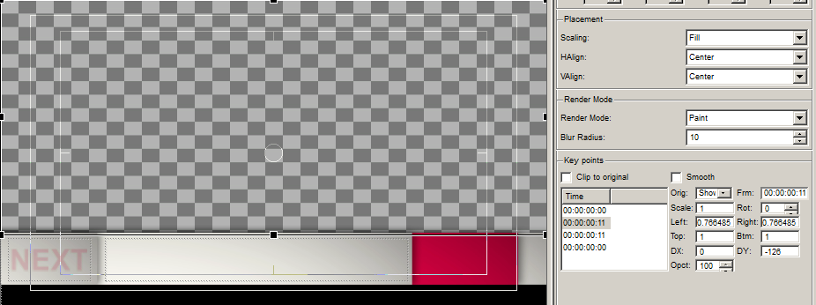
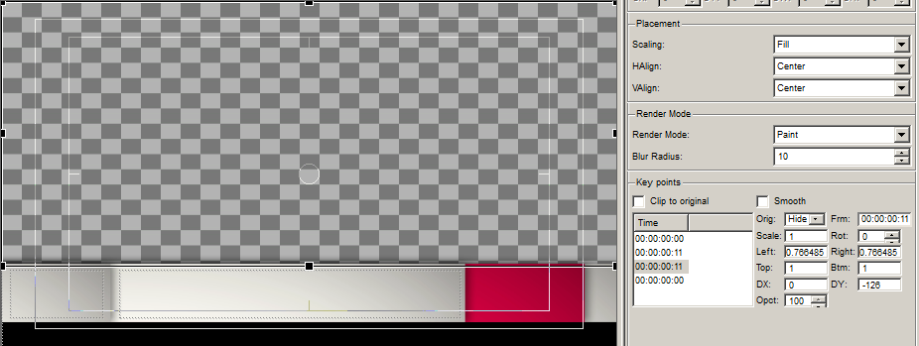
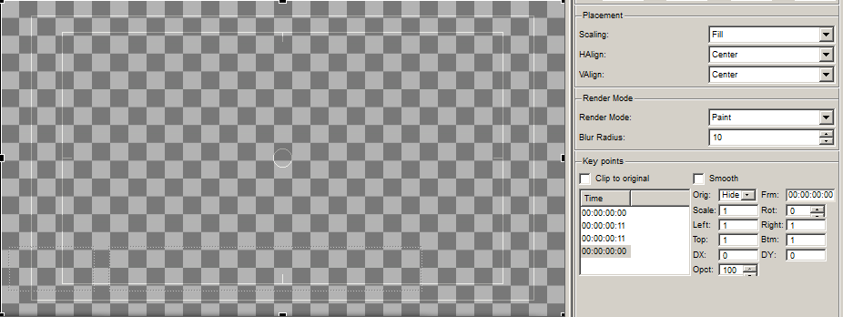

Black solid
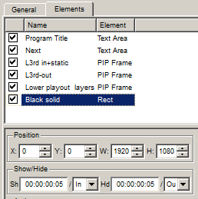
As the L3rd in+static lower third has a transparent area between it and the frame lower edge, there is a Rect element serving as the backing for this transparent part.

Broadcasting Composition On-Air

Download example
The 2017 media base contains a composition example: Effects/Squeeze.

