Adjusting and Normalizing Output Level of SL NEO Server Audio Signal
Functionality of SL NEO server software allows adjusting the output level and normalizing the output audio signal. The functions are useful while forming SDI-signals with embedded sound, and especially when forming IP/ASI transport streams, so as in the last case installing de-embedders/embedders and hardware devices for audio processing is unavailable or inappropriate. Let’s look at the details of configuring the functional at the server platform.

Adjustment of Output Audio Level
Adjusting parameters is implemented from the control panel - Administrator Control Panel. Login to the console is implemented locally from the server or from any computer in the network at http://server_ip:7901. Login to the control web console as an administrator.
After the login to the control console, select Manage at the menu. Find the Video IO Boards tab and start editing parameters of a corresponding Playout service. Find the Base Audio Level field in the General tab and set the value in decibels that will be used to increase or decrease the output audio level.
The function is applied to all audio tracks in the output audio signal of the selected Playout service, the default value is 0 dB. The level regulator is placed in the final chain of the server audio-path.
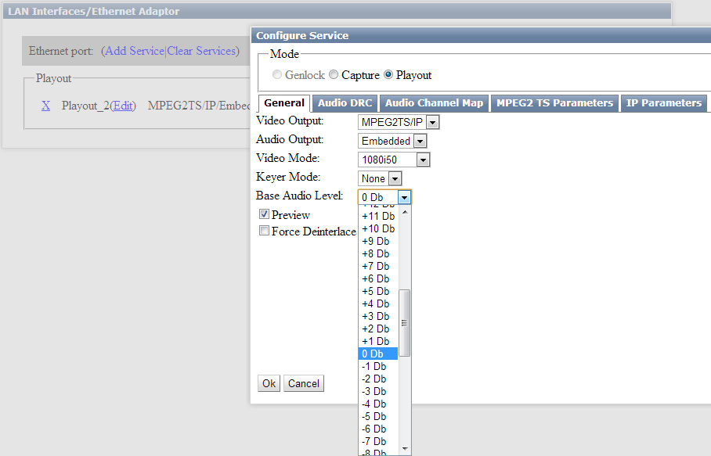
At the end of editing, press Apply in the top of the control console window to apply changes.

Normalization of Output Audio Level

Compressor
The function of normalizing the audio level is provided for manual and automatic import of media files to the SL NEO server storage. Besides, you can activate the built-in compressor/limiter (the function DRC - Dynamic Range Compression) for on-line post-processing of audio signals formed by the server.
With different audio levels in played back files and signals that come to server inputs, the Audio DRC software module (placed at the output part of the server audio-path) increases or decreases the transfer ratio. Thus, the average output audio level is maintained unchangeable. The Audio DRC module works both with monophonic signals and multi-channel audio, simultaneously processing up to 16 audio channels within one server output playout channel.
Audio DRC works with all types of output signals and interfaces supported by SL NEO servers: SD/HD SDI/HDMI, Audio Embedded, AES EBU, Analog Audio and DVB IP/ASI transport streams. Parameters of program compressors/limiters of every output server channel can be individually configured.
Configuring parameters of level automatic adjustment is implemented from the control panel - Administrator Control Panel. Select Manage in the console menu, then pick the output device for configuring: find the Video IO Boards tab and edit parameters of the corresponding Playout service.
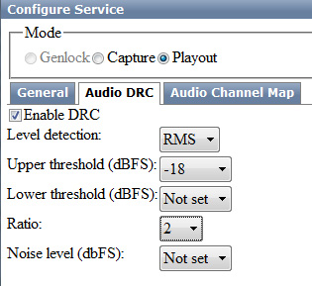
The Audio DRC tab contains settings for normalization of output audio level.
Parameter | Description
Enable DRC | The option launches the level processor
Level Detection | Defines the compressor triggering type:  - Peak - triggering by the level peak values. This way is used to limit the signal peak values to a certain threshold.  - RMS - triggering by the level average value. The RMS-compressor can miss short signal peaks with practically no decrease to the transfer ratio. The RMS-method is mostly used in compressors for volume leveling, so as loudness is more connected to mean-square capacity rather than peak capacity.
Upper Threshold (dBFS) | Sets the threshold for compressor triggering by the dBFS scale - the input level value, exceeding of which makes the compressor weaken the signal (see the levels diagram). Setting this parameter is traditionally used for “leveling” the generated program.
Lower Threshold (dBFS)
Ratio | Sets the ratio defining the weakening (Upper Threshold) or amplifying (Lower Threshold) intensity of the output signal by the compressor when exceeding/understating the input level. The value is expressed in the “x:1” format. For instance, with the ratio “2:1”, Upper Threshold exceeded by 10 dB will make the compressor weaken its “level of exceeding” by half, to 5 dB.  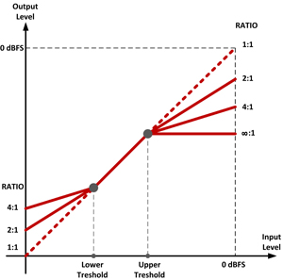
Noise level
The compressor doesn’t allow to adjust the Attack time and Release time parameters.
Attack time displays the speed necessary for scanning the audio signal so to consider changes in the sound level. The set value of 200 msec is selected as the most optimal one.
The parameter Release time defines the time needed for the compressor to return to the condition of regular gain after the signal falling lower the inflection point. The set value about 5 msec is the minimum one.

Limiter
The limiter is the same compressor with the set Upper Threshold value, configured to limit the output level when exceeding the input one: input to output signal ratio starts from the 8:1 value. When using harder limitation, undesirable nonlinear distortions may appear in the output signal.
At the end of editing the Audio DRC module parameters, press Apply at the top of the server control console, to save the implemented settings.

Download
To see the Audio DRC module work in the RMS mode, use the avi-file containing fragments of a 1kHz signal with different levels (from -42 to 0 dBFS). The video contains information on the current levels values in a file - measuring the audio level from the server output, you can test the compression degree and correctness of settings.

