Anchors
Starting from version 2.3.12, Graphics Editor has the function of anchoring coordinates of a graphic object vertically and horizontally with other objects in the graphic composition.
The media_db_1080i50_20180307_2392 demo database contains an example of how the Anchors function works.
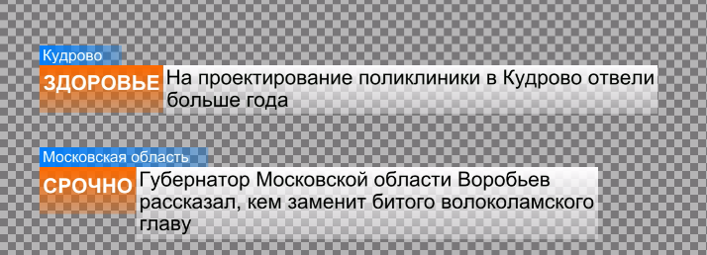
ObjectAnchorDemo elements are anchored, which allows them to adapt to text content specified through parameterization from the playlist.

Setting
To anchor object A to object B, open Anchors in object A properties. After anchoring, resizing object B, or moving it will affect object A.
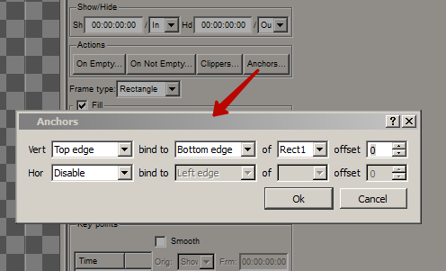
Option | Value
Vert | Vertical anchoring – selecting the parameter of the initial object to be anchored:  - Disable – anchoring inactive  - Top edge – anchor the top edge of object A,  - Bottom edge – anchor the bottom edge of object A,  - Height – anchor the height of object A.
bind to (Vert) | Vertical anchoring – selecting the parameter of the object to anchor to:  - Top edge – to the top edge of object B,  - Bottom edge – to the bottom edge of object B,  - Height – to the height of object B.
Hor | Horizontal anchoring – selecting the parameter of the initial object to be anchored:  - Disable – anchoring inactive  - Left edge – anchor the left edge of object A,  - Right edge – anchor the right edge of object A,  - Width – anchor the width of object A.
bind to (Hor) | Horizontal anchoring – selecting the parameter of the object to anchor to:  - Left edge – to the left edge of object B,  - Right edge – to the right edge of object B,  - Width – to the width of object B.
of | Setting the name for the target object to anchor to (object B)
offset | Setting the anchoring offset, in pixels. A positive value sets the indent, a negative value sets the overlap.

