Capture Source: Internal Signal Switching Control Module
The module for switching inputs of Capture services (IPTS, WEBCAST, NDI), and Playout, Profanity Delay, TimeShift, ProgramChannel BG input streams through the video switcher interface and RtClient. Added in version 2.4.117.

Scheme
The image shows an example of possible interaction of software modules upon using Capture Source.
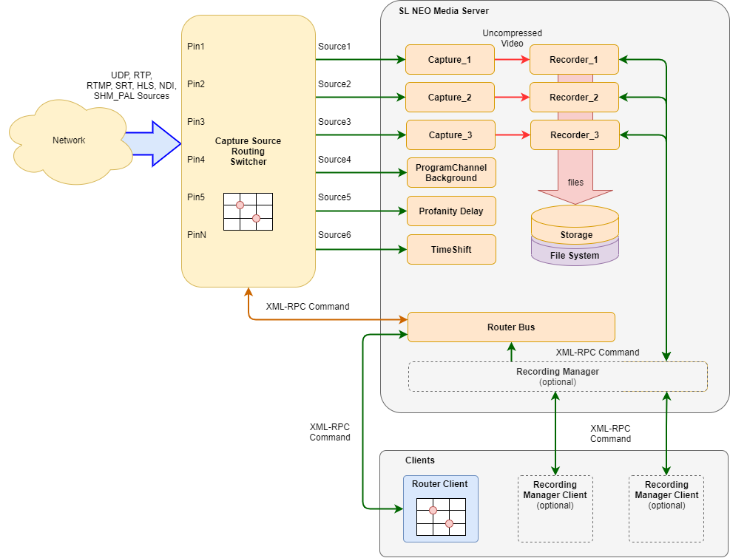

Setting
Stop the server through Stop Server in the right click menu. In the Configure Server Components window add Internal/Capture Source into the server current configuration by dragging the component to the right part of the window. Start the server through Start Server in the right click menu.
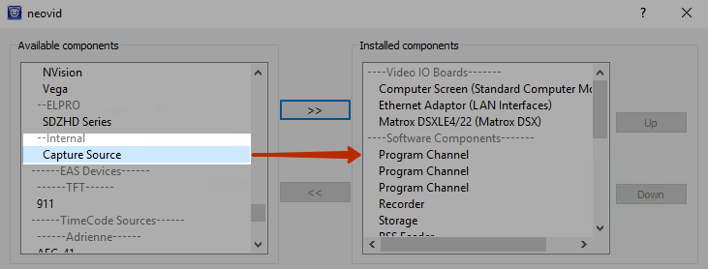
Activate the selected component in the server settings: Administrator Control Panel → Manage → Router Buses → RouterBus_N → Service Enabled.
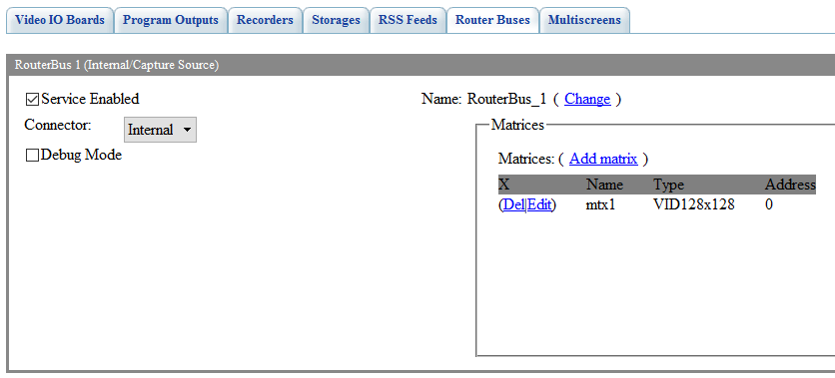
Option | Description
Service Enabled | Activating the virtual matrix service
Connector | Not used
Debug Mode | Activates the debug mode for logging additional information
Name | The service name used for calling actions. The Change button opens the dialog for editing the name.
Matrices | The list of configured matrices. Add matrix opens a dialogue for adding a matrix.
The dialog for adding/editing the matrix
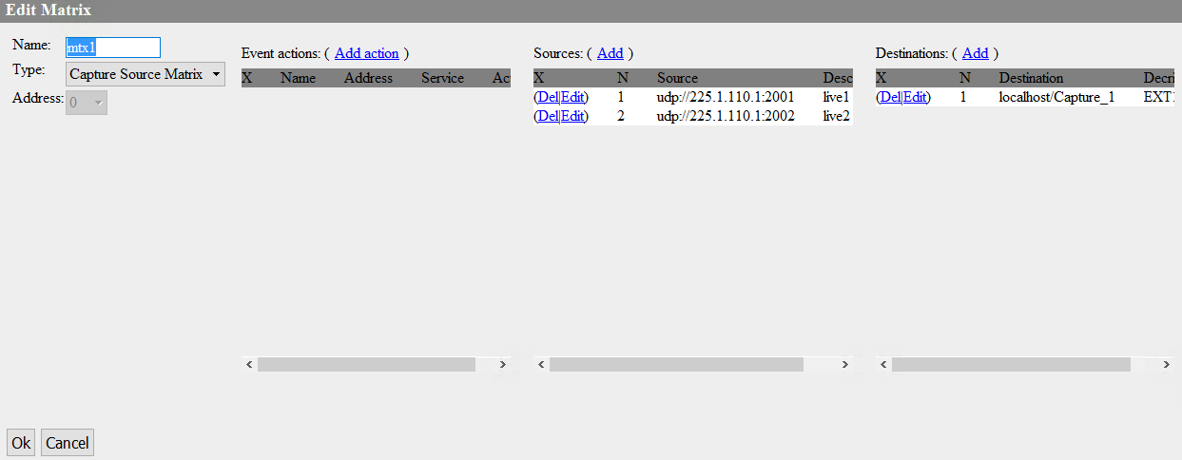
Option | Description
Name | The matrix name. Used upon configuring the connection, e.g. in RtClient
Type | The type of matrix. The only value Capture Source Matrix is available by default
Address | Not used
Event Actions | The list of actions that may be launched by event triggers: DST Connect to SRC and DST NOT Connected to SRC. The dialogue for adding a new action:  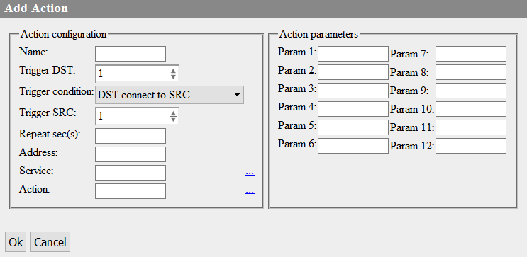
Sources | The list of inputs (sources) and corresponding Source Pin values
Destinations | The list of outputs and corresponding Output Pin values
The dialog for adding inputs (sources). Pin numbers are assigned automatically.
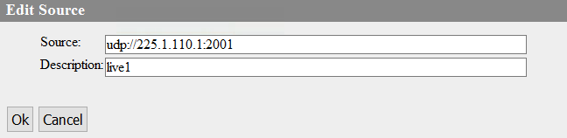
Option | Description
Source | The signal source.  - For IPTS sources:  - xxx.xxx.xxx.xxx:port[@pgm=N][@vpid=N][@apid=N]...[@apid=N] set pgm, vpid and api to -1 to pick the first one available in the stream  - For WebCast sources:  - rtmp://host:port/addr  - http://host:port/addr  - udp://addr:port  - For NDI signal::  - COMP (NAME)  - For local services:  - shm_pal://SERVICE_NAME, where SERVICE_NAME is the service name, e.g. Capture_1
Description | Description
The dialogue for adding matrix outputs. Outputs are services controlled by the Source parameter (Playout, Profanity Delay, TimeShift, ProgramChannel Background). Pin numbers are assigned automatically.
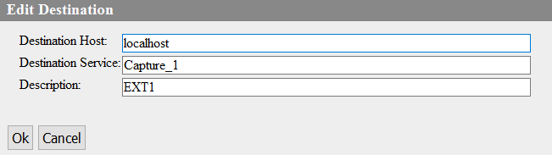
Option | Description
Destination Host | The server IP address or localhost, is the service is located at the same machine as RouterBus
Destination Service | The name of the service to select sources for. For example, Playout_1.
Description | Description

