Ember+ Device Management Module
GPI Board for device management through Ember+ added in version 2.7.28.

Adding Module
Stop the server before adding a new module. Right click Neovid near the clock and select Neovid→Stop Server in the opened window.
Open Neovid → Configure Server Components.
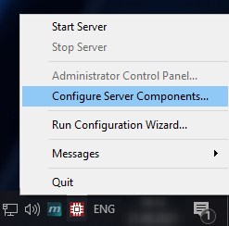
Move Device Server → GPI IO Boards → Ember+/Generic device to the right part of the window using the arrow button. To control several remote devices, add the appropriate number of modules.
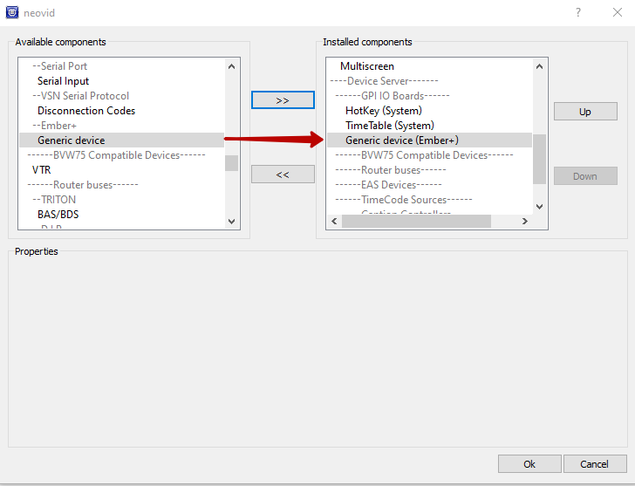
Press OK and start the server: Neovid → Start Server.

Configuring
Open the server control panel, find settings of the added module on Neovid → Administrator Control Panel → Manage → GPI Boards → GPI Board (Ember+/Generic device), and start it by checking Service Enabled.
Press Configure Provider… to specify the data for connection to the remote device through Ember+.
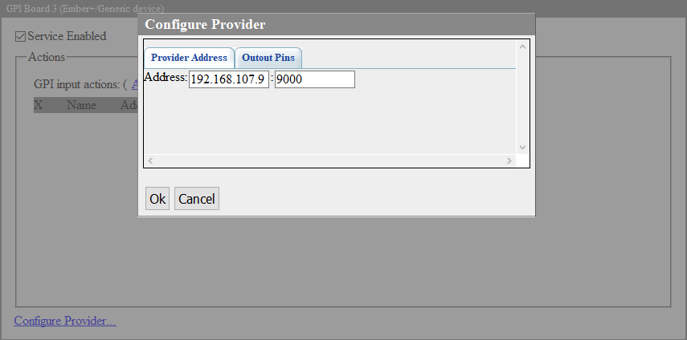
Provider Address | Data for connection
Address | Address of a remote device supporting Ember+
Port | Number of the remote device port used for connection
Output Pins | List of parameters
Output Pin | A conditional number used in actions to send commands to the remote device. The number is linked to the parameter ID of the remote device with the controlled value.
Parameter ID | Ember+ identifier on the remote device. The value is edited by pressing ….  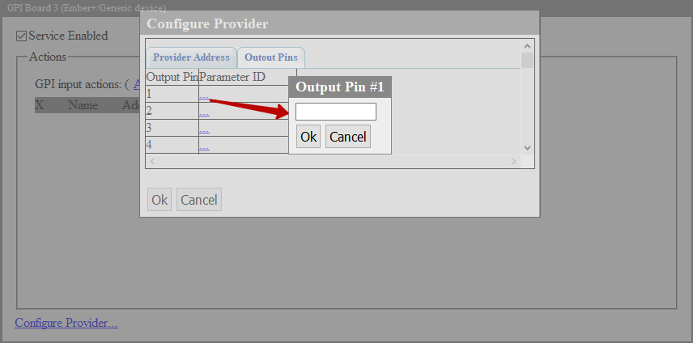
At the end of configuring, press Apply Changes at the window top part.

Management
When the module is successfully configured, you can use it to manage your Ember+ device.
The GPI Board module's Do Command action accepting three parameters is used for that:
Parameter | Description
Param 1 | Executable action. Specify “set” in this field.
Param 2 | Pin number. Use one of the numbers configured on the Output Pin tab. At this stage, the pin number will be broadcast to the Ember+ parameter ID on the remote device.
Param 3 | The value transferred to the remote device. Refer to the instruction for your Ember+ device.
This action may be used as any other actions, e.g. SCTE Messages Generation or DTMF. For instance, you can transfer commands to the audio mixer based on executable playlist events. More about the action mechanism here.

Troubleshooting
If remote device management does not function, open Neovid → Messages → GPIBoard_N and check that connection to the remote device is successful.
If there are problems with the connection, you will see a message like:
Connecting to XXX.XXX.XXX.XXX:PORT
connection failed
In this case, make sure that:
- the connection details are correct.
- the remote device is running and connected to the same network as the Skylark server.
- Ember+ support is enabled on the remote deivice.

