Genlock
Skylark SL NEO servers support phasing the output SDI signal by line and frame relative to the reference analogue video signal at the REF IN input (depends on a used SDI board). Both a regular video signal and a black burst video signal can be used as a synchronization signal.

Settings Description
Configuring Genlock parameters is implemented in the SDI output board properties: Administrator Control Panel→Manage→Video IO Boards→Board→Genlock input.
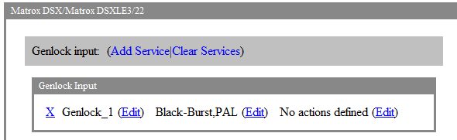
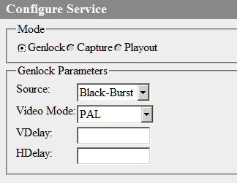
Parameter | Value
Source | Select a reference signal source:  - Black-Burst – use an external black burst reference signal (feature available in Matrox boards).  - FreeRun – use an internal generator (feature available in Matrox boards).  - Auto – automatic mode selection (feature available in Blackmagic boards).
Video Mode | Defines the mode of an input REF signal.
VDelay | Vertical Delay – adjusting the value of delay by frame. Adjustment is implemented with one line pace within 0-625 lines. On Matrox DSX LE4 boards, the VDelay parameter is configured individually for every Playout output (available since version 2.3.95).
HDelay | Horizontal Delay – adjusting the delay value by a row. Adjustment is implemented with 1 ns pace within 0-63963 ns (0-864 pixels). On Matrox DSX LE4 boards, the VDelay parameter is configured individually for every Playout output (available since version 2.3.95).

Phasing
The scheme of connecting measuring equipment for phasing the server SDI output (screenshots with Tektronix WFM2300 Waveform Monitor are used in the example).
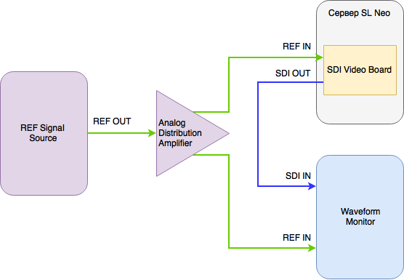
Make sure that the oscillograph is in the External Reference mode and the correct output is selected.
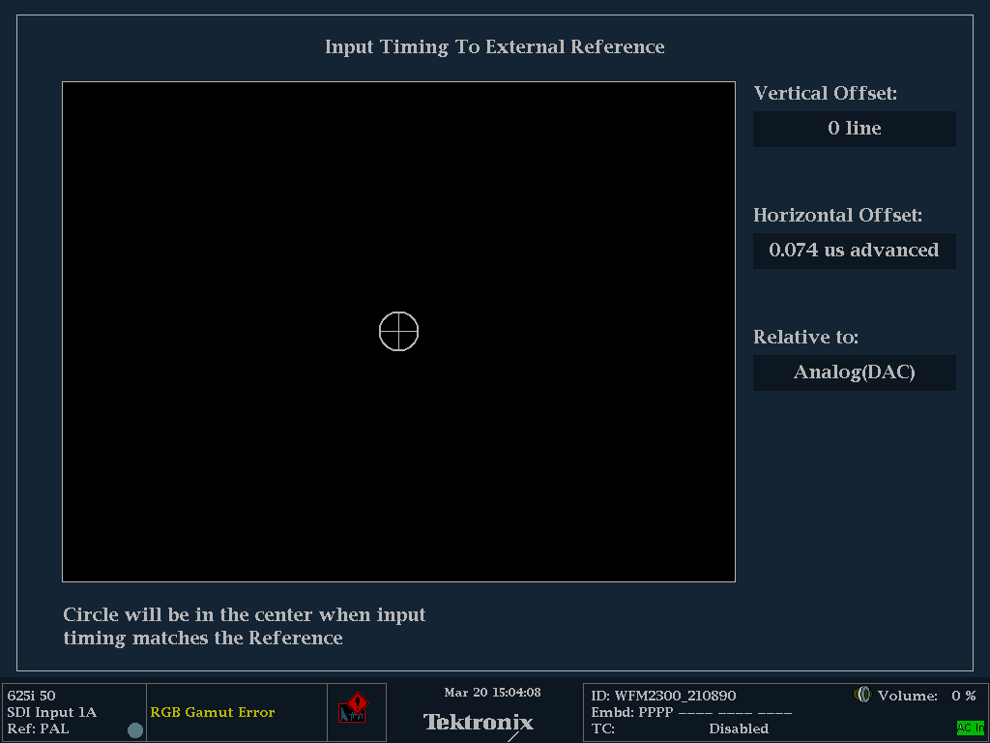
The screenshot displays how the output SDI signal outruns REF by 0 rows and 74 nanoseconds.
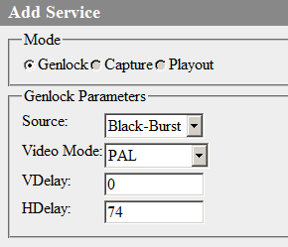
Set the appropriate value in the HDelay field to delay frame output by 74 ns.
At the end of configuring, press Apply Changes at the top of the control console window. The Genlock (or Playout for Matrox DSX LE4 boards) service will be reloaded, playback on the server will be suspended.
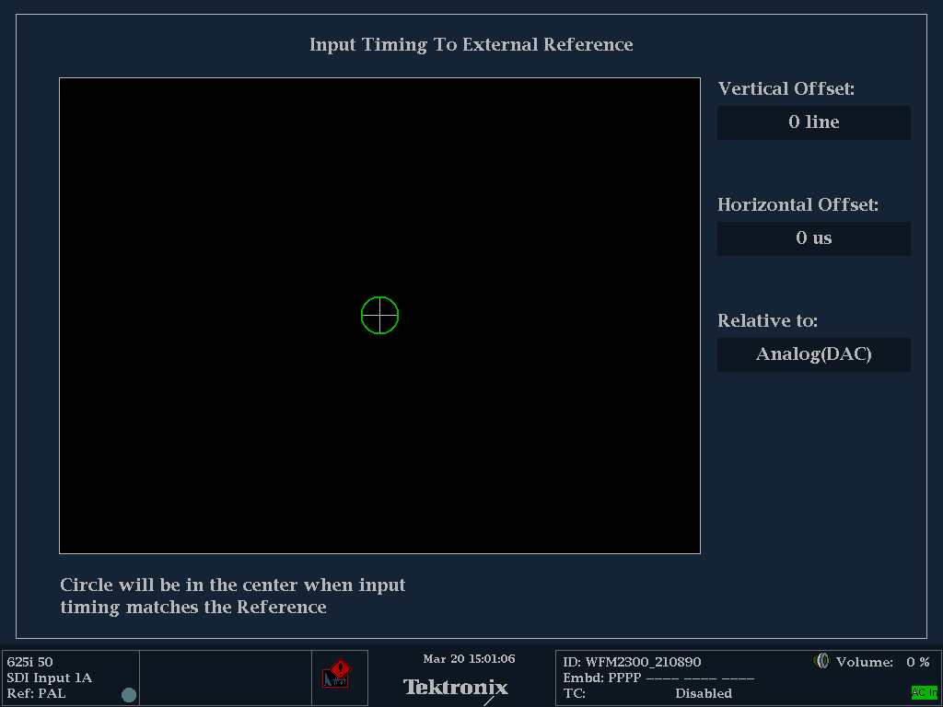
Retesting shows that shift relative to the reference signal is fully compensated.

