Godot Engine (Events)
The Godot Engine module can accept user commands and parameters from loaded scenes, allowing you to customize certain Actions on receiving such a command (Event).
The information is relevant for version 2.9.42.100 and later.

Scheme
The image shows an example of interaction between software modules.
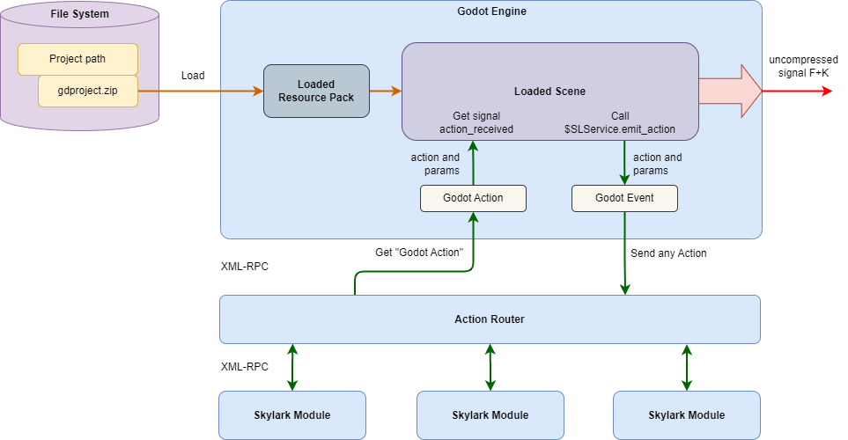

Transmission
The command names and number of parameters are determined by the scene developer, depending on the tasks to be solved. The emit_action method of the SLService node is used to transmit commands:
$SLService.emit_action(name, params);
Where:
- name (String) - random name of the command sent to Godot Engine.
- params (PackedStringArray) - array of parameters that can be passed to the Godot Engine module.

Receiving
In Godot Engine settings, the Trigger field specifies the name of the expected command. Param1-ParamN fields may contain variables with values of the parameters passed from the scene. The variables are specified in the %1…%9 and/or %A….%Z format. For example, %1 or %A will contain the value of the first passed parameter).
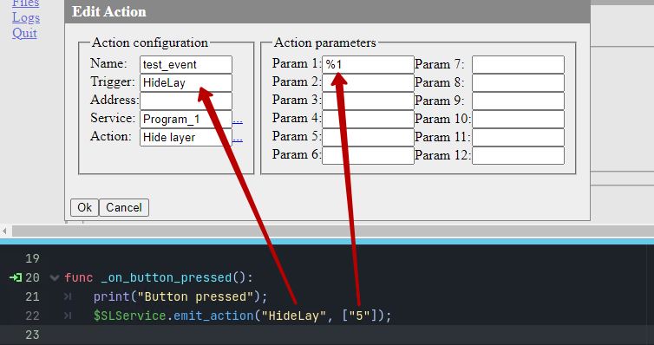
Example of settings to disable the 5th graphics layer when receiving a user command from the scene.

