Switching Output URLs for Playout in HLS and RTMP
The information is valid for 2.11.16 version and newer.
The Playout module in RTMP and HLS modes can now be configurable on-the-fly by setting the destination URL dynamically.

Management Options
Dynamic addition and removal of Endpoints manually or using the action mechanism is supported.
Multiple URLs can be added simultaneously, and when active, they will all send a Playout signal to the appropriate Endpoint.

Control via the Action
Use the "Set Output URL" action in the Playout module.

Manual control
Dynamically set destinations can be monitored and managed on the Status tab: Administrator Control Panel→Status→Playout_N→Output Url.
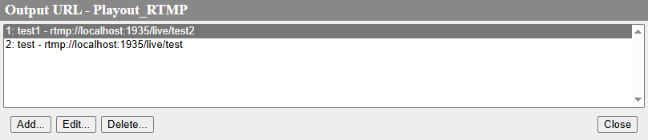
Parameter | Description
Add | It opens a window for adding a new URL.
Edit | It opens a window to edit the parameters of an existing URL.
Delete | It deactivates and deletes the selected URL.
Close | It closes the window.
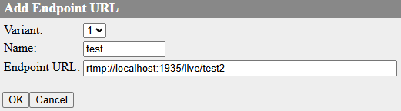
Parameter | Description
Variant | When adding a new URL, you are given a choice of All, 1, 2, 3. Once saved, this field cannot be changed.
Name | An arbitrary name for this endpoint.
Endpoint URL | URL address of the endpoint.
  The correctly specified URL is the user's responsibility. The output URL must be of the same type as the mode selected in the Playout configuration, i.e. RTMP if RTMP is selected in the Playout configuration or HLS if HLS is selected in the Playout configuration.
OK | It saves the changes made.
Cancel | Exit without saving.

Playout HLS
The default endpoints defined in the Playout module settings and the HLS Publishing option will run in parallel with dynamically set endpoints added at runtime. If there is no endpoint configuration in the module settings, the configuration is considered valid and all output of this playback will only be produced according to endpoints added at runtime or by HLS publishing.
In HLS mode, endpoints are always added at once for all variants with the same URL.
The HLS output type supports the following protocols which can be freely mixed for different endpoints:
- http - например, http://localhost:7901/hls/playlist.m3u8
- https - например, https://localhost:7944/hls/playlist.m3u8
- file - например, Z:\hls_out\playout4.m3u8

Playout RTMP
In RTMP mode, endpoints are added for each variant individually. Using a “0” variant to set all output variants at the same time is not allowed and will result in an error.
The RTMP output type supports the following protocols which can be mixed freely for different endpoints:
- rtmp - например, rtmp://localhost:1935/live/stream1
- rtmps - например, rtmps://localhost:443/live/stream1
- file - например, Z:\stream1.flv

