Licensing the Skylark Media Platform

General
The Skylark SL Neo software and BMPlayer are protected against copying by a software key, which depends on the hardware used and some other components.
Everyone who wants to test the Skylark software products in their entirety is given a temporary license for up to 3 months. In order to get a temporary key you need to provide your contact information and go through a simple activation procedure.
.

Description of NeoVid license fields
Field | Value | Description
Skylark Technology Inc. NeoVid version 2.0.10 2015-04-15 |  | Software version and build date (used to calculate Upgrade expires)
Machine CODE: | ATDM-PAGC | The current machine code which depends on the hardware
Config CODE: | IMSV-CZOG | The current configuration code
Config SD Channels: |  | Number of configured SD inputs+outputs (playout and capture services)
Config HD Channels: | 4 | Number of configured HD inputs+outputs (playout and capture services)
Config 4K Channels: |  | Number of configured 4K inputs+outputs (playout and capture services)
Config PGM Channels: | 4 | Number of program channels configured (playlists, program channels)
Config REC Channels: |  | Number of configured recording services (recorders)
Config PDS Channels: |  | Number of Profanity Delay Channels
Config LCC Channels: |  | Number of channels using Live Closed Captions
Config SCTE104 Channels: |  | Number of channels generating SCTE104 (no license required for label reception)
Config EBU-R128 Loudness Channels: |  | Number of channels using EBU-R128 level normalization on Playout output (no license required for normalization on import)
Config Graphics Channels: | 4 | Number of program channels using Graphics Channels (the Layer Playlists Enabled option was activated in the program channel settings). Added to the 2.7.x line.
Ext CII Channels |  | The number of activated ExternalGraphics Controller modules is "CII Compatible"
Ext VizRt Channels |  | Number of activated ExternalGraphics Controller modules - "Vizrt/MSE/IGH"
Licensed to: |  | parameters of the license installed in the system
Name: | 3344M8 | license name. often the name of the server model is specified here
Machine: | ATDM-PAGC | Licensed machine code
Config: | line | Licensed configuration code
SD Channels: | unlimited,0-N | Number of available SD channels
HD Channels: | unlimited,0-N | Number of available HD channels
4K Channels: | unlimited,0-N | Number of available 4K channels
PGM Channels: | unlimited,0-N | Number of available program channels
REC Channels: | unlimited,0-N | Number of available recording services
PDS Channels: | unlimited,0-N | Profanity Delay Channels
LCC Channels: | unlimited,0-N | Number of available program channels with Live Closed Captions activated
SCTE104 Channels: | unlimited,0-N | Number of available channels with SCTE104 tag support
Config EBU-R128 Loudness Channels: | unlimited,0-N | Number of available channels with normalization support
Graphics Channels: | unlimited,0-N | Number of available software channels with graphic design support. Added to the 2.7.x line.
Storage Connections: | unlimited,0-N | Number of allowed network connections to the Storage service from different IPs
Ext CII Channels | unlimited,0-N | Number of ExternalGraphics Controller modules available - "CII Compatible"
Ext VizRt Channels | unlimited,0-N | Number of available ExternalGraphics Controller modules - "Vizrt/MSE/IGH"
Expires: | 2021-05-01 | The expiry date of the license for trial licenses. If the current date is later than the date specified in this field, the license will be considered invalid. Check the value of this field in the license file before installing the license.
Upgrade expires: | 2021-05-01 | The expiration date of the upgrade period. The value of the field is checked against the value in the first row of the table. If the build date of the installed software is later than the date specified in this field, the license will be invalid.
Licensed modules: | server, basic_mam, archive, transfer, airmgr, newscut, maconnect, recmgr, cpmedia, ezmuxer | List of licensed modules separated by commas
License is | VALID or NOT VALID | License status

Description of license fields for other modules
Field | Value | Description
ezmux_channels | 8
ezmux_groups | 2
mamserver_connections | 20 | Number of simultaneous connections to MAM WebAccess
mamserver_servers | 1 | Ha multiple MAM WebAccess can be run on the same server. This parameter sets the maximum number of WebAccess that can be used.

Licensed modules
Module | Description
bmplayer | Activation of Skylark Broadcast Media Player
server
basic_mam | Basic functions MAM (XMP circuits, shortcuts, user rights. BINs)
archive | Support for tape archive as part of MAM
transfer | Transfer Manager - transfer manager
transfer_lite | transfer Manager]] version of Transfer Manager licensing, which allows you to change the container, but does not allow you to do transcoding. Added to 2.7.x.
airmgr | Air Manager - client program
newscut | News Cut - client program
maconnect | Media Connect - client program
recmgr | RecManager]] client program
cpmedia | licensing the cpmedia module. Required when this module is used standalone
cpmedia_lite | cpmedia licensing option which allows to change the container but does not allow to do transcoding. Added to 2.4.26.
r128loudness | Activates Loudness support in the NewsCut app
messenger | Option integrated in MAM messenger. Added to 2.4.81.
ccdv
ccgateway
ezmuxer | EazyMuxer - transport stream multiplexer
vodd | Functions VOD
mamserver | Activates the MAM WebAccess component (web archive management)

Example license file
additional_info=FOR TEST ONLY
expires=2021-02-01
ezmux_channels=8
ezmux_groups=2
machine=XXXX-XXXX
modules=server,transfer,airmgr,ezmuxer
name=6340E1
srv_channels_graphics=3
srv_channels_hd=5
srv_channels_lcc=0
srv_channels_loudness=0
srv_channels_pds=0
srv_channels_pgm=0
srv_channels_rec=4
srv_channels_scte104=0
srv_channels_sd=0
srv_channels_uhd4k=0
srv_channels_vdcp=0
srv_storage_conn=15
upgrade_expires=2021-02-01

How to install (upgrade) a license

By copying the key file
Start by checking your license file that you plan to install. Make sure that it is named license.lic. Rename it if necessary.
Place your license file in the folder:
- SL NEO package (Neovid, AirMgr, Transfer Manager, etc.) - C:\Program Files (x86)\SL NEO Media Platform\run\license.lic
- BMPlayer - C:\Program Files\BMPlayer\run\license.lic.
To apply the license you will need to restart the server modules and client software.

Through the interface on the server
Application of the license data is performed without restarting SL NEO Media Server.
You can install or update the license on the server through the server control panel: SL NEO Media Server→License.
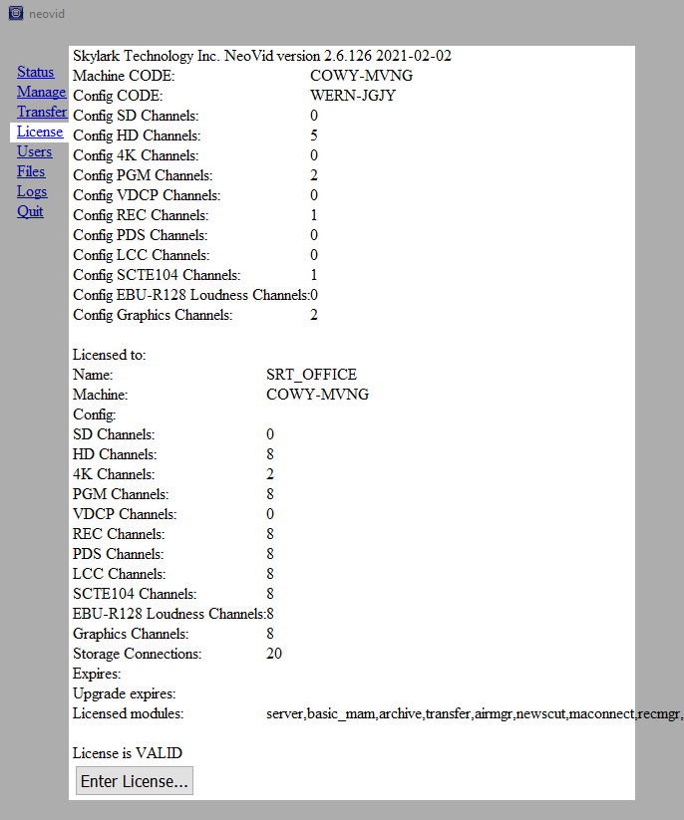
Click Enter License and copy all the data from the license file. 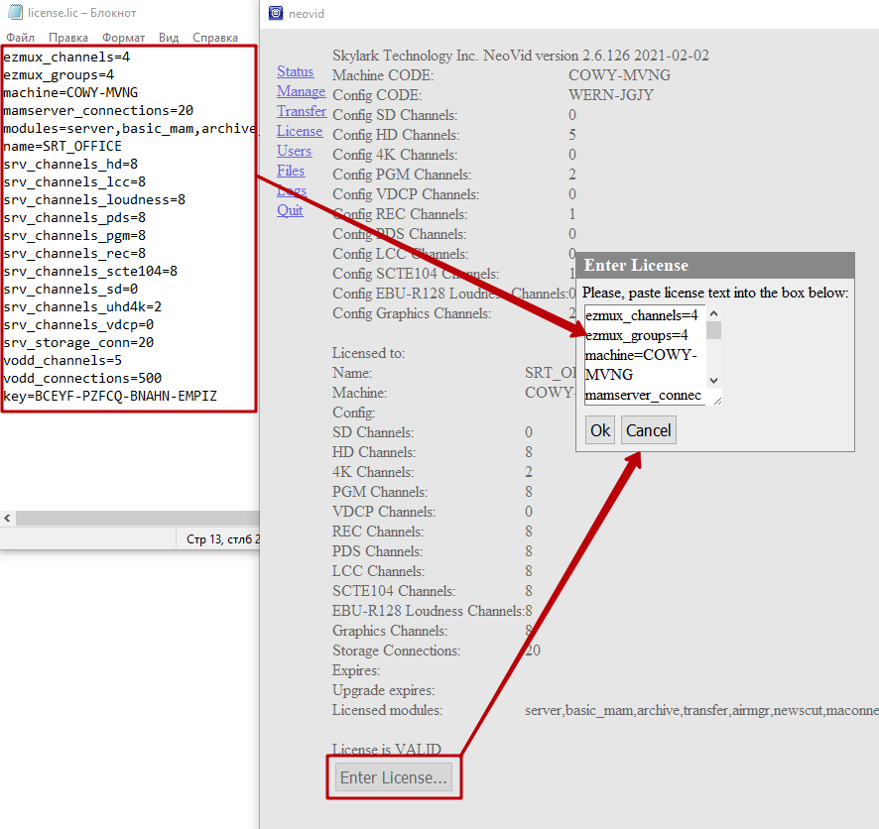

Through the client application
Installing or updating a license on a client workstation can be done through a client application such as Air Manager or Media Conenct:Air Manager/Media Conenct→Help→License….
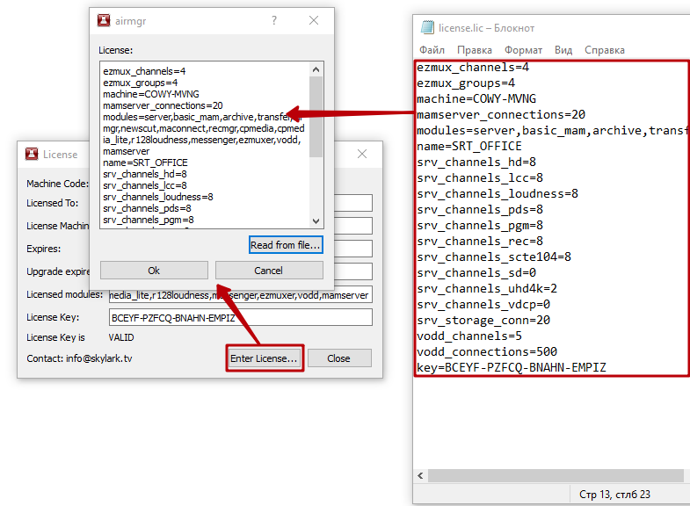
You may need to restart the client software to apply the license.
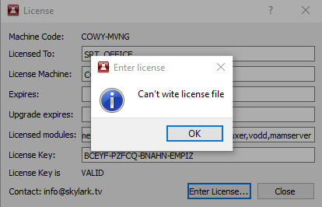
If you receive a “Can't write license file” error message, you need to run the client application as an administrator to ensure that the license file is written successfully.

Batch licensing
When the client software is launched on network clients from a shared folder, it is necessary to save several license keys in one location simultaneously. This is provided by the batch licensing mechanism, which allows you to include machine code in the license file name added in 2.4.33.
An example of naming the license files: license-XXXX-XXXX.lic, where XXXX-XXXX is the code of the corresponding machine.

Limitations of the SL Neo demo version
The SL Neo software automatically enters demo mode if the license status is “NOT VALID” and the “SL NEO Media Platform http://skylark.tv” message appears over the image on the Playout and Recorder services. The imported footage duration limit of 8 minutes is enabled. Some features described in the software manual may not be available in demo mode. To test some of these features you need a full license with a limited validity period - a trial license. EzMuxer works for 72 hours in demo mode, and then the services stop.

Limitations of BMPlayer demo version
BMPlayer automatically goes to demo mode if license status is “NOT VALID”: DEMO is displayed in preview window and “Demo mode” information message pops up every 5 minutes.

