Increase the number of graphic layers by controlling PIP objects
The actions described in this article will require a basic knowledge of setting up program channel, creating graphic compositions, using API.

Task
We need to output age markers, but there are no free graphics layers, as they are all already used to output graphics on a regular basis.

Solution option
You can use a graphic composition with PIP objects as containers for reproducing other graphic elements and compositions. That is, one PIP object would conventionally add us one more controllable graphic layer. One graphical composition, occupying one real graphical layer, can contain several PIP objects, which allows to realize layer sharing. The PIP objects within the graphical composition will be managed through API.

Setup

Creating a composition
Create a graphics_editor infinite-length composition and add to it the number of empty PIP objects you plan to control. Let's name the composition “pip_layers”.
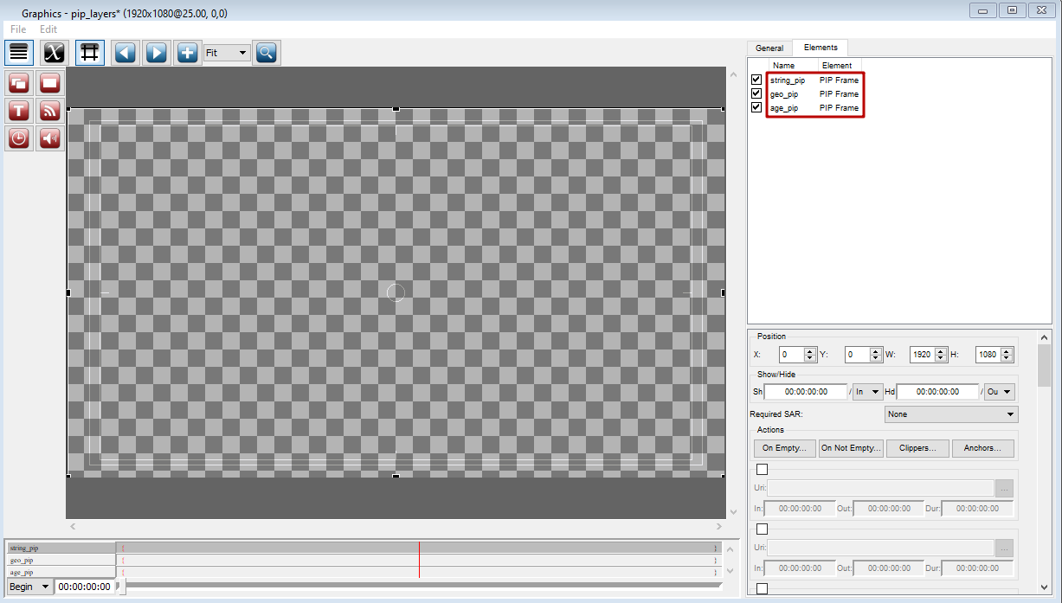
Give the PIP objects unique names.
. Remember that the names of all graphic elements within graphic compositions being played in the program channel at the same time are in a single namespace. If two elements from different compositions have the same name, you may get unexpected results when you try to control them through the API.

Adding action
Go to program channel settings and create a new action that will load the age16 graphic composition with the age marker 16+ into the PIP object. For other markers the actions will be similar.
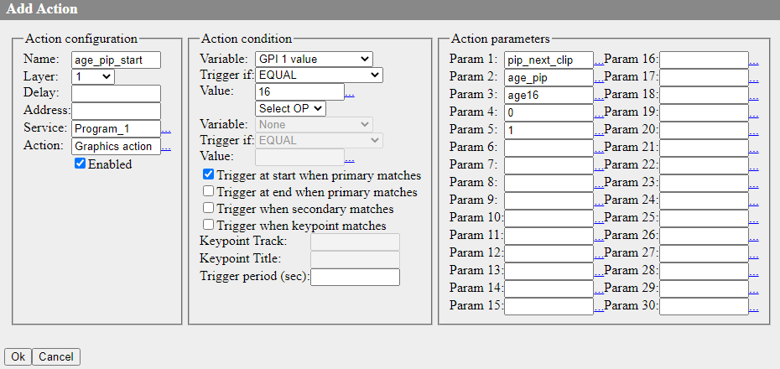
Let's take a closer look at the action settings:
Parameter | Opinion
Name | The arbitrary name of the action that will be displayed in the control panel
Layer | The number of the layer where the action will be triggered
Service | The name of the program channel that will execute the action
Action | The name of the action to be executed. You must select “Graphics action”
Action condition | In this area we set the condition that must be fulfilled in order to start the action. In the example we have specified that the action will be executed on the start of the event on the base layer if it has a value of 16 in the GPIv1 column.
Action parameters | Specifies the set of parameters that will be passed when the “Graphics action” action is executed
Param 1 | The graphics API command to be executed. In our case the “pip_next_clip” command will be used, which adds a new clip to the play queue of the PIP object and allows it to run immediately.
Param 2 | Sets the name of the PIP object to which the command will be passed.
Param 3 | Sets the name of the clip you want to add and play in the PIP object.
Param 4 | Defines whether the clip should be repeated cyclically. 0 - the clip will not be repeated.
Param 5 | Defines the auto playback start of the clip after it is added. 1 - start playback immediately.
. Remember that if you apply the updated settings, the program channel service will restart. This will cause playback to stop and the broadcast will be interrupted.

Using
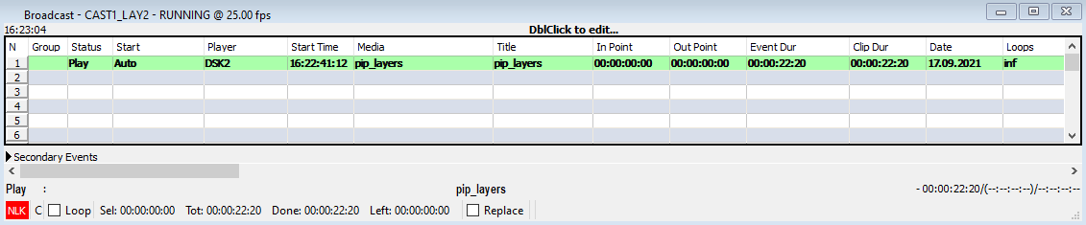
Add the “pip_layers” graphic composition to the freed graphic layer, start playing it, and then wait for the condition to trigger the previously configured action.
The “age16” composition will automatically play inside the “age_pip” PIP object from the “pip_layers” composition.

