Administrator Control Panel - WEB-console to control server settings. Part 3. Section Manage

Program Outputs tab
The Program Outputs tab allows configuring the parameters of SL NEO Program Player - the server module responsible for playing the events from the playlist and forming the so called “program” channel. Program Player forms an uncompressed stream with audio and video data, the resulting composition consists of several video layers:
- Backgroung (BG) - full-screen layer, as a rule - signal from server input;
- Main Layer - The main full-screen layer, overlapping the BG layer according to the events in the playlist. The main layer is formed by file materials and Live clips;
- Graphics layers, managed by separate playlists (one for each layer), which contain the design clips. In addition to playlists, graphics layers can be formed with individual compositions/files (maximum number of layers: playlists + compositions with graphics =8).
- Logo layer, controlled manually or automatically from the playlist.
During the playlist execution, according to the events, SL NEO Program Player can control not only the file playback, but also generate commands to external devices: matrix switchers, GPI - devices and graphic design servers of SL NEO line. The control commands from Program Player go to the modules of SL NEO platform, which directly manage the devices (Device Server modules).
The role and place of the Program Player module in the software environment of the SL NEO server is illustrated by the figure (configuration of the 3000 series server is represented):
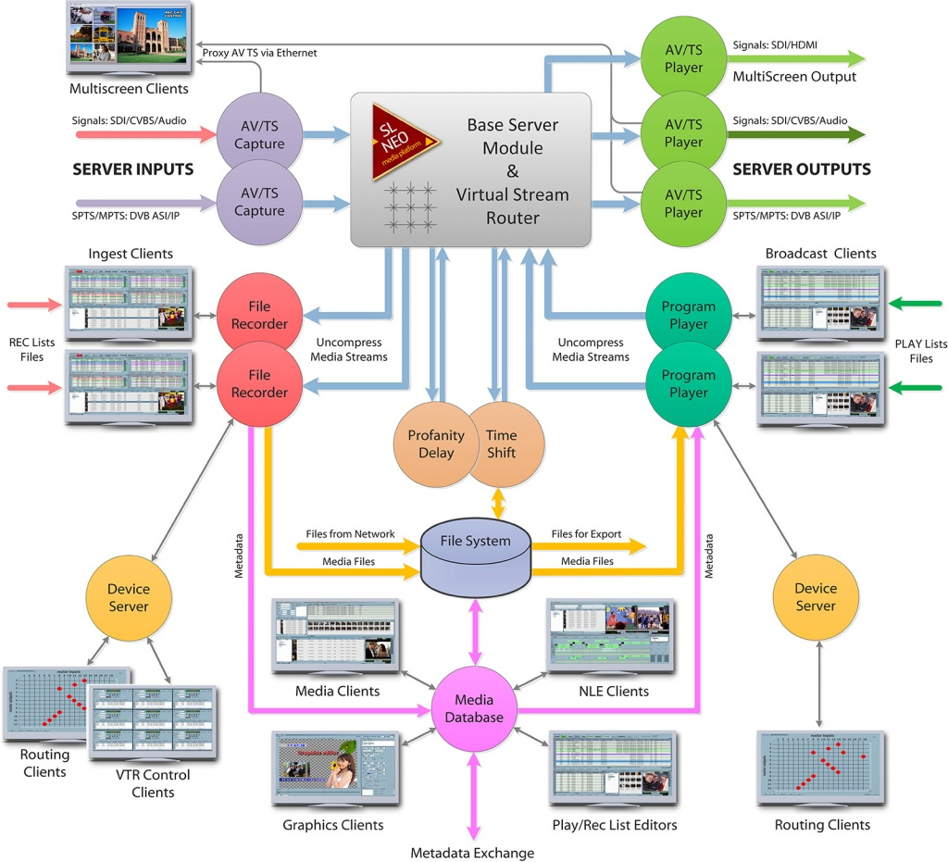
The SL NEO Program Player module settings window (Program Outputs tab) in turn contains several tabs:
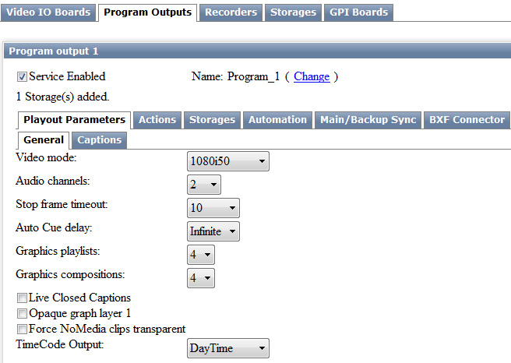

The Playout Parameters tab
The Playout Parameters tab is responsible for adjusting the parameters of the module's output stream (the Video Mode and Audio Channels fields).
The next two parameters are used to configure the server for convenient work in the studio and during live broadcasts when the operator starts the shots in the “manual mode” (the Manual start type is mostly used):
In the Stop Frame Timeout field set the time in seconds during which the server output will display the last freeze frame of the clip after the end of its playback, or after the operator stops the playlist at the Stop command.
In the Auto Cue Delay field, set the time for which the clip that is next in the playlist for playback and has the Manual start type will be automatically prepared for playback. During the time equal to the Auto Cue Delay value, the command of Cue preparation will be automatically executed, the first frame of the clip will appear at the server output, and then you will have to press Play to play it - see description of Top Menu commands of the Air Manager client software.
The values specified in the Graphics Playlists and Graphics Compositions fields form the ratio of “playlists graphics + compositions with graphics” layers. Maximum number of layers =8 (without logos) for each program channel. This number is set during initial setup of Program Player in Configure Server Components (Program Channel section). The “default” value is 4.
Live Closed Captions allows you to enable closed captioning on the Program Player output. When the output stream from Program Player is fed to the AV/TS Player input, subtitles will be generated in the VBI/VANC interval in the output SDI in accordance with CEA-608 for SD or CEA-708 for HD.
The active Opaque Graph Layer 1 item makes Graph Layer 1 opaque, which makes it possible to place full-screen material in the playlist of this layer and to “overlap” the main playlist layer without making any changes in the progress of its playlist. The key point here is to “overlap” not only the video sequence, but also the audio track of the main layer. If the Opaque Graph Layer 1 item is inactive, putting full-screen clips into the graphic layer's playlist is also possible, but in this case the audio tracks of the main layer and the graphic layer will be mixed.
The active item Force No Media Clips Transparent makes the main playlist layer visible in case there is no media data in the playlist line of the graphic layer #1 for some reason (the message in the playlist line is No Media). This mode is intended to work together with the Opaque Graph Layer 1 mode.
The Time Code Output field allows you to activate the generation of a time code stream at the output of the Program Player module. When the output stream from Program Player is fed to the AV/TS Player module input, the signal containing the TC will be generated in the VBI/HANC interval in the SDI output in VITC for SD and PR188 for HD format.

Storages tab
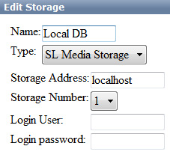
Storages tab - specifies for SL NEO Program Player the sources for file playback. Local or network folder with media files or SL NEO Media Database - a server module performing the function of a database for media content can act as a source. Several sources can be configured for file playback.
When configuring the Program Player module, this tab should be referred to first, because the absence of references to file sources will not allow the module to play anything. In most cases, you should use the source - SL NEO Media Database.
Why a database and not just a folder with files?
SL NEO Media Database allows users to interact with the materials/clips rather than with the files on the disk, and not to waste time wondering what folder the material is in, what will happen to the broadcast if the file is moved to another folder, how to start watching and playing the material immediately after the start of recording, how to view comments and other attributes, how to watch the same material by several network users simultaneously in proxy-quality and without causing damage to the broadcast playback?
The key advantage of using the SL NEO platform DB is the use of a single cached connection to the local RAID server, where all recording-playback services, all network user requests are done only through this single connection. As a result, no Windows Net Bios is used and all the artifacts associated with the use of SMB protocol and “shared” folders are eliminated, there is no need to connect “network drives”, users do not work with OS files, but with “clips” (actually - with proxy-copies of materials, viewing and editing them), resulting in a minimal additional load on the network and disk arrays.
Setting up connection of Program Player to file sources is done as follows:
- Use the Add button on the Storage tab to open the appropriate window for selecting a source.
- Select SL Media Storage as the source, and specify the name of the previously configured Storage_1 database service. In the Storage Address field you can specify the IP address of the server where the SL NEO Media Database service is activated (in case of network playback). When using local database service you should specify localhost or leave this field empty.

Actions tab
The Actions tab is responsible for setting up execution of rules and commands.
The Actions tab is a system of rules and commands implemented in the SL NEO server software and allows setting up the execution of certain actions by the server in case of the specified conditions. The condition for rule execution can be, for example, coincidence of values in the rule and in the playlist column. When a condition occurs, the server performs the specified action. Each type of service (Program Channel, Caprure, Recorder, etc.) has a specific set of actions, the execution of which can be configured in the rules.
There are 4 types of rules for the SL NEO Program Player module:
- Playlist events - actions execution by modules (Capture, Recorder, Program Player, etc.) at occurrence of certain conditions “inside” the playlist. Such conditions can be: coincidence or noncoincidence of values in the playlist columns with the values specified in a rule. Command execution is regulated by additional parameters for each rule.
- General events - execution of actions by modules (Capture, Recorder, Program Player, etc.) when the playlist goes to a certain state (for example - start or stop of the playlist).
- Background events, Main Layer events - actions performed by the modules (Capture, Recorder, Program Player, etc.) when certain events occur in the BG layer (Background) or Main Layer (Main Layer): execution of the command when detecting black box, freeze frame, etc.

The Automation tab
The Automation tab allows you to configure the basic functions of the built-in automation system for broadcasting, for the work of which the Program Player module is responsible.

Main/Backup Sync tab
The Main/Backup Sync tab allows you to configure synchronous operation of the main and backup SL NEO servers.
When you have finished configuring the module, you need to save the changes you made - the Apply Changes button at the top of the control console.

