Skylark Media Platform Basic Structure

Skylark Media-Server Components
- Server Industrial Version
- Special Graphic I/O Board
- SL Neo Media Platform Software
- Additional Equipment: GPI Modules, Panels, etc

SL NEO Server Line
Depending on the purpose, there are 11 models of media servers:
- SL NEO 1000 Multichannel Recording Servers
- SL NEO 2000 On-Air Broadcasting Servers
- SL NEO 3000 Universal Multifunctional Servers
- SL NEO 4000 Broadcasting with Time Shift and Profanity Delay
- SL NEO 5000 Graphic Design Servers
- SL NEO 6000 Servers for Recording and On-Air Monitoring
- SL NEO 7000 Instant Replay and Slow Motion Servers
- SL NEO 8000 Multiscreen Processors
- SL NEO 9000 MPEG-2/H.264 Multichannel Encoders
- SL NEO DB-А Database Servers for Media-Archive Management
- SL NEO VOD Video-on-Demand Servers
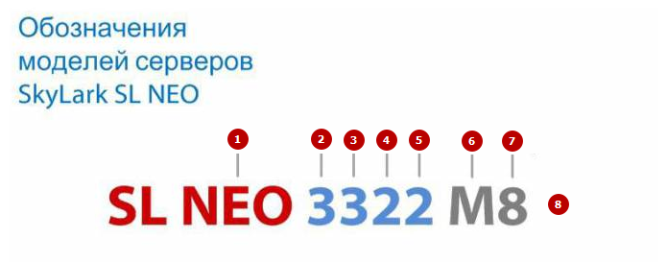
Model Explanation
N | Description | Possible values
1 | Series name | SL NEO
2 | Series number (see the product line above) | 1-9
3 | Configuration type | - 1.2 – SD  - 3.5 – HD/SD  - 4.6 – 4K UHD/HD
4 | The number of inputs (ingest channels) | 0,1-N
5 | The number of outputs (playback channels) | 0,1-N
6 | I/O platform type | - M - Matrox DSX  - D - DecTek DTA  - B - Blackmagic Decklink  - P - DataPath  - E - Ethernet  - S - Streamlabs
7 | Built-in RAID-capacity | 4,8,12 etc.
8 | Additional Information | - HR - HD Ready (Hardware for HD, license for SD)  - SW - specified server model software only

Skylark SL NEO Distribution Kit
The setup file is provided on a CD/DVD/Flash drive or loaded from the Internet. The demo version is sent on demand, contact info@skylark.tv. A single setup file has a full set of server and client software and the entire codec collection. SL NEO software runs on Windows 7 SP1 (64 bit) or Windows 2008 Server.
Actual Software Version

Software Installation
Skylark SL NEO software installation process is simple and standard.

Apps in Distribution Kit
Server applications (blue icons)
SL NEO Media Server (neovid.exe) | The main server application, consists of different modules: capture, playout, programchannel etc.
Transfer Manager (transfermgr.exe) | Transfer Manager is the program complex providing automatic transcoding and transfer of media and metadata files between assemblies of production and broadcasting complexes (МАМ, Windows folders, SL NEO media servers, NLE stations, work stations).
Eazy Muxer (eazymuxer.exe) | The multiplexer for working with IP/ASI transport streams
VOD (vodd.exe) | The Skylark VOD service allows creating a VoD (Video on Demand) Internet portal that implements the system of individual delivery of TV programs and movies from Skylark media-server in various formats.
MAM WebAccess (mamproject.exe) | Skylark MAM Web Access Server provides the cross-platform client web app that allows working with materials in the server browser МАМ media database.
Client applications (red icons)
AirManager (airmgr.exe) | Playlist and rec-list management, import to and export from the media database, creating graphic compositions
Media Connect (maconnect.exe) | Managing archives, access rights and statuses, creating graphic compositions etc.
Multiscreen (multiscreen.exe) | Controls inputs/outputs of software graphic modules (capture, playout, programchannel, recorder, multiscreen)
NewsCUT (newscut.exe) | News editing with basic effects
RecManager (recmgr.exe) | Efficient recording queue management
Router Client (rtclient.exe) | The interface for remote control of matrix switchers
Live Panel (livepanel.exe)
Bus Switcher (buswitcher.exe)
VTR Playlist (playerlist.exe)
VTR Dude (vtrdude.exe)
TS Test (tstest.exe) | The built-in analyzer of transport streams
DumpCast (dumpcast.exe) | Transport Stream Playout Module (supplied separately from the distribution kit).
DumpSched (dumpsched.exe) | Playlist Export Module for Vi (supplied separately from the distribution kit).

