Configuring Actions in Capture Service
The Capture service can analyze different parameters of the input signal, providing an opportunity to configure execution of certain Actions in case of triggering an event.
Information in this article is eligible for Background Events and Main Layer Events settings of the Program Channel.

Analyzed Parameters
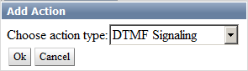

DTMF Signaling
DTMF is a dual-tone multi-frequency analogue signal.
DTMF cue-tone is a sequence of DTMF signals used for automation of commercials inserts and blocks of regional broadcasting to the air of the main channel.
The DTMF technology work principle is the following: SL NEO server is constantly analyzing the input audio-signal from the central station. The analyzer built-in to the Capture service detects tones in audio channels and forms a control command every time, when it finds a DTMF cue-tone corresponding the specified mask.
In case if the received tone coincides with the mask and according to the rules of reaction to a cue-tone, the server automatically gives a command to play a local advertising block and implements program switching. You may set the time of delay from the moment of detecting the tone to start of playout and program switching. The end of an ad block may be detected in the same way. In this case, the server will form a command to stop the playlist with commercials and switch the source.
DTMF tones can be accepted and decoded by the SL NEO server from any types of input signals: SDI+AE, AES, Analog Audio, DVB ASI/IP TS. Input tones are detected automatically, no additional settings for duration and level of sendings are required.
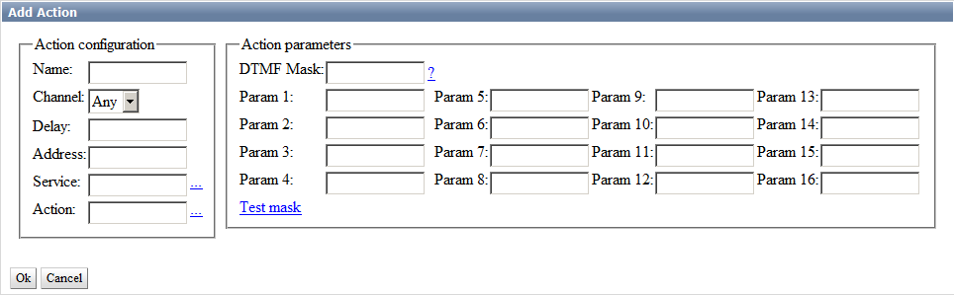
Parameter | Description
Name | Random name for the created rule
Channel | Select an audio-channel from 1 to 16 to pass cue-tones, or enter Any to search for tones in all channels.
Delay | Specify the time of delay from the moment of receiving the tone till command execution, in milliseconds. The value can be only a positive number.
Address | IP address of the server that receives the command. | Leave the field empty, if the value is localhost.
Service | Name of the service to be managed by the rule. Pick the value from the list by clicking “…”.
Action | Executable command (Action). Pick the value from the list by clicking “…”.
DTMF Mask | A sequence of any number of symbols acceptable for DTMF (0123456789ABCD*#), and so-called substitutional symbols. There are two substitutional symbols: “_” that conforms any input signal, and “+” that conforms any sequence of input signals, including an empty sequence. You can also use braces to specify parts of the mask line for using as triggering parameters. For example: the “*(+)8(+)#” mask conforms the DTMF tone starting with the “*” symbol, has “8” in the middle and ”#“ in the end.
Param 1-16 | Using parameters depends on a selected action.
Test mask | Allows checking sequence correctness in the DTMF Mask parameter.  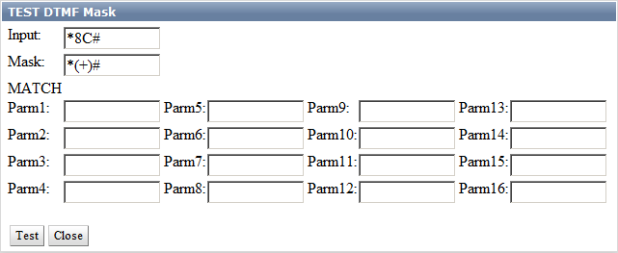  - Input – sequence estimated input value  - Mask – specified detecting mask  - Test – button to launch checkup  - Possible results:  - NOT TESTED – checkup not performed.  - MATCH – input sequence fits the detecting mask and the rule will trigger.  - MISMATCH – input sequence does not satisfy the mask criteria and the rule will not trigger.

Fixes
- 2.4.58 – DTMF detector now always uses the «dtmf_sensitivity» setting («normal», «lower», «low») in the «run/vars» file. Usage example: dtmf_sensitivity=normal.
- 2.4.26 – added option in DTMF detector, which allows selecting a pair of audio channels with opposite phases as a channel.
- 2.0.40 – improved identifier of DTMF cue-tones.
- 2.0.38 – processor of DTMF tones suppresses duplicate triggering during 4 seconds when processing multi-channel sound.
- 2.0.33 – the maximum time of connecting DTMF tones is 500ms (was 200ms). Important! After updating to this or later version you may need correction of triggering delays, if you used DTMF somewhere.

Examples of DTMF Cue-Tones
- STS TV-channel

Additional Information
- Configure Receiving DTMF Cue-Tones to Manage Playout of Regional Commercials
- Configuring Generation of DTMF Cue-Tones in Central Station Output Signal

VBI GPI (Softel)
GPI in VBI commands analyzed – signals in the 16th line (Softel protocol).
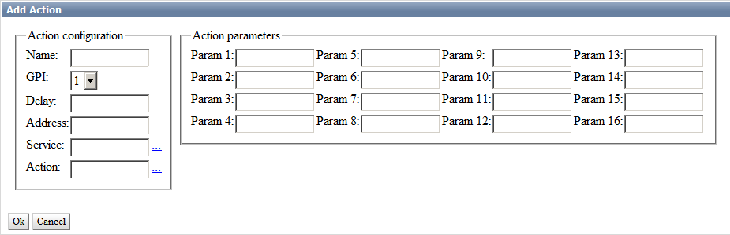

Video Detection
The working principle of the technology for analysing video fragments is the following: SL NEO server is permanently tracking the input signal and comparing video fragments previously recorded to the disk against the input signal content. In case of coincidence, the set action can be implemented.
The feature is used, for instance, in regional inserts: in case of fragment coincidence, the server automatically implements program switching and sends the command for playout of a local ad block. The end of an ad block may be detected in the same way. In this case, the server forms a command to stop the playlist with commercials.

Creating Video Fragment for Analysis
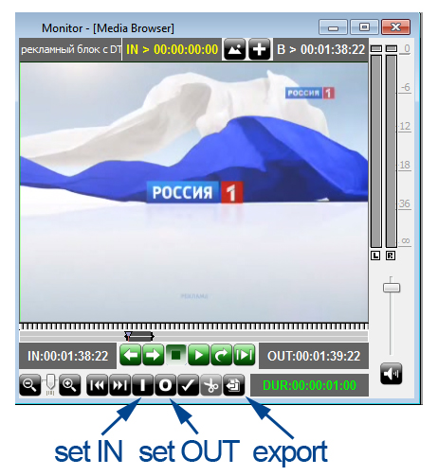
The input signal from the central station must be preliminarily recorded. Then, in the File Monitor window of Air Manager, look through the needed fragment and mark it with a duration no longer than one second, export this fragment as a file to the server disk, into the folder C:\Program Files (x86)\SL NEO Media Platform\run\files.
Recording is not necessary, if the corresponding media-file already exists. You may upload the file into the selected folder remotely, using the control web-console of the server (menu item Files/Upload file).
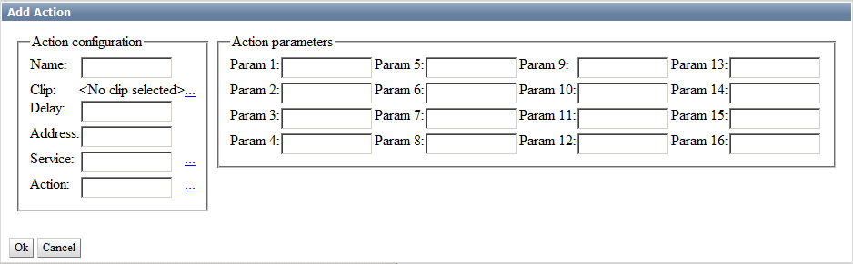
Parameter | Description
Name | Random name for the created rule
Channel | Select an audio-channel from 1 to 16 to pass cue-tones, or enter Any to search for tones in all channels.
Delay | Time of delay from the moment of receiving the tone till the command execution, in milliseconds.
Address | IP address of the server that receives the command. | Leave the field empty, if the value is localhost.
Service | Name of the service to be managed by the rule. Pick the value from the list by clicking ”…“.
Action | Executable command (Action). Pick the value from the list by clicking ”…“.

Still Frame Detection
The analyzer detecting freeze frames and black bursts.
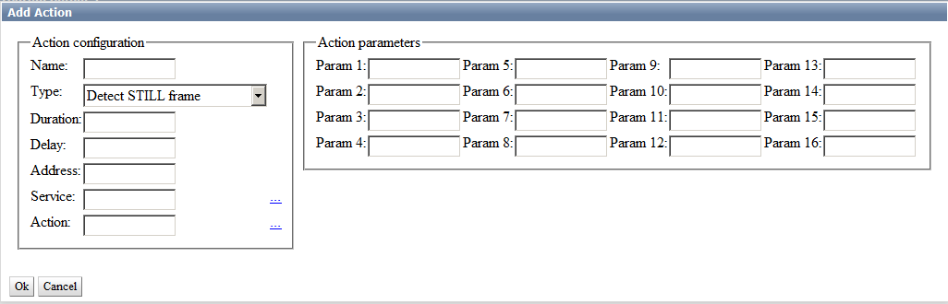

Line23 Signaling
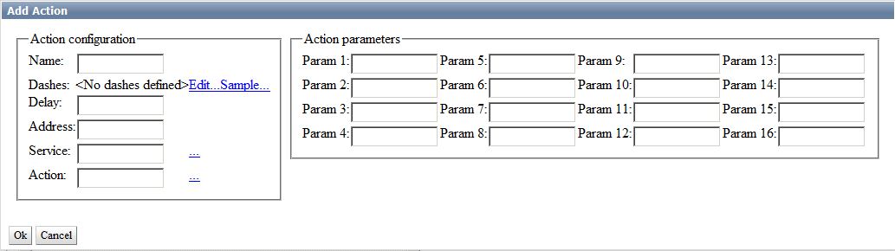
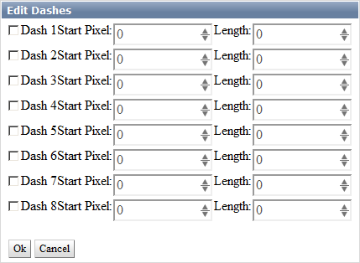

SCTE-104/35
SCTE-104 messages are part of the technology for automated insert of commercials and contain control information for regional broadcasting systems.
SCTE-104 data is located in the 12th line of the SD/HD SDI signal VANC interval.
The MPEG-encoder receiving SD/HD signals from the SL NEO server at the central station, also receives information about the message and forms an additional PID in the transport stream, according to the SCTE-35 protocol.
Using SCTE-104 messages within SDI, and SCTE-35 messages within a transport stream extended to the channel broadcasting territory, allows the regional system to identify the received program and every insert event, define with frame-by-frame accuracy the beginning and end of an insert, and implement transition to the ad block with the specified ID.
Besides, using SCTE messages provides confidentiality and safety from unauthorized commercial inserts. Regional broadcasting systems using the technology of automatic inserts, can function in an autonomous mode, which considerably decreases exploitation costs.
SCTE-104 messages are usually generated directly before transitions to commercials, and before the end of every regional block, providing frame-by-frame accuracy. In case of manual transitions to commercials during live broadcasts at the central station, generating messages with frame-by-frame accuracy is still available.
The analyzer built-in to the Capture service detects messages in the input stream and forms a control command (executes an action) every time, when it finds a message.
SCTE-35 messages can be received and decoded by the SL NEO server from DVB ASI or UDP IP sources of input signals.
SCTE-104 messages can be received and decoded by the server from VANC-data as a part of input SD/HD SDI signals.
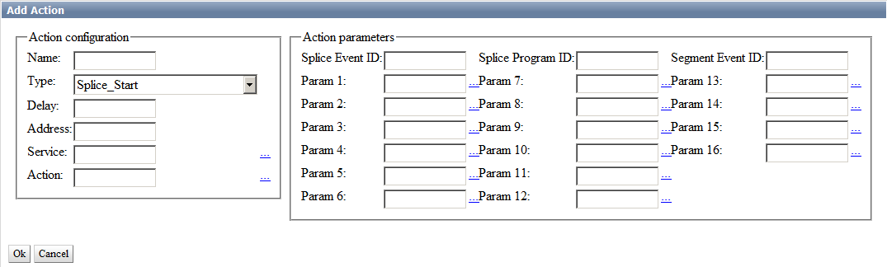
Parameter | Description
Name | Random name for the created rule
Type | Type of event sent in the message:  - Splice_Start  - Splice_End  - Program_Start  - Program_End  - Program_Breakaway  - Program_Resumption  - Chapter_Start  - Chapter_End  - Provider_Advertisement_Start  - Provider_Advertisement_End  - Distributor_Advertisement_Start  - Distributor_Advertisement_End  - Placement_Opportunity_Start  - Placement_Opportunity_End  - Unscheduled_Event_Start  - Unscheduled_Event_End
Delay | The time of delay from the moment of receiving the message till command execution in milliseconds, for providing frame-by-frame accuracy. When receiving SCTE-104/35 commands, the analyzer automatically pins dubbed input commands (with decreasing delay) and considers the preroll time specified in the command. Negative delay values lead to command execution in advance.
Address | IP address of the server that receives the command. | Leave the field empty, if the value is localhost.
Service | Name of the service to be managed by the rule. Pick the value from the list by clicking ”…“.
Action | Executable command (Action). Pick the value from the list by clicking ”…“.
Splice Event ID | Ad block identifier
Splice Program ID | Program identifier
Segment Event ID | Program segment identifier.

Additional Information
- Transmitting Data in TV Signal
- SCTE-104 Standard Description (pdf)
- SCTE-35 Standard Description (pdf)

Temporary Deactivation of Message Detection
Sometimes you may need deactivation of message detection: for example, during a live broadcast. Specific actions Disable Action handler and Enable Action handler are used for that.

