Working with GPI Devices
Skylark servers support a variety of GPI devices.
List of supported devices with the number of available I/O ports:
Device | Input Ports | Output Ports | Additional Information
ICP DAS P8R8 | 8 (optically isolated, digital) | 8 (relay) | PCI board
ICP DAS P16R16 | 16 (optically isolated, digital) | 16 (relay) | PCI board
ADLink PCI-7250 | 8 | 8 | PCI board
ONTRACK ADU200 | 4 | 4 (relay) | USB module
ONTRACK ADU2x8 | 8 | 8 (relay) | USB module
XKEYS XK-60 | 60 (keys) |  | Xkeys 60-key USB keyboard
XKEYS XK-80 | 80 (keys) |  | Xkeys 80-key USB keyboard
System HotKey | 64 (combinations) |  | Windows system keyboard
System TimeTable | 64 (timing) |  | System startup scheduler
Louth Protocol Event Decoder | NA | NA | COM port
Stramatel Protocol Score Board | NA | NA | Scoring system, COM port

Processing GPI Commands
For some types of GPI devices, Skylark uses Pin, a temporary identifier for the command, which allows the input command from the device to be linked with one or several actions simultaneously. Some devices transmit Pin directly: for example, the X-Keys keyboard.
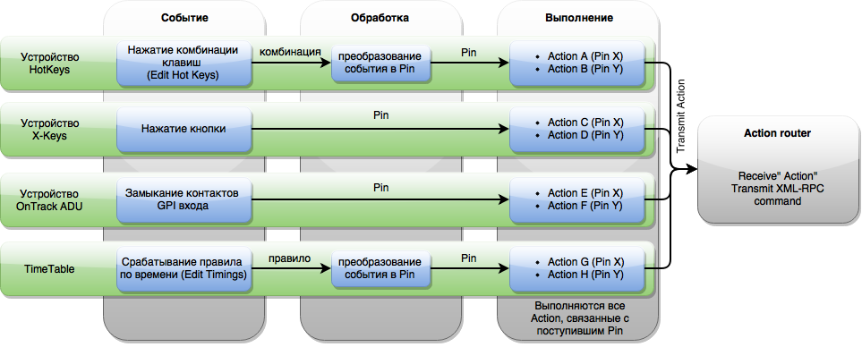
This diagram illustrates processes in the GPI Board module. For a general overview of how GPI Board interacts with other system components, see Action Router.

Adding
The new device is added in the GPI IO Boards section of the server components configurator.

Settings
The settings of added GPI devices are on the tab Administrator Control Panel → Manage → GPI Boards → GPI Board N.
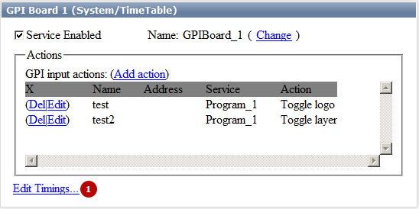
Parameter | Value
GPI Board N (DEVICE) | N – service number, DEVICE – device model
Service Enabled | Setting the checkbox activates the selected service
Name | Service system name
Change | Change service name
Add Action | Open the dialog for processing input GPI commands. Output GPI commands can be generated by actions.
Del | Remove action
Edit | Edit action settings
(1) | Additional settings. Not all devices require additional settings, the value depends on the type of device selected:  - ICP DAS P8R8 – N/A.  - ICP DAS P16R16 – N/A.  - ADLink PCI-7250 – N/A.  - ONTRAK ADU200 – serial number settings (Edit Serial No.).  - ONTRAK ADU2x8 – serial number settings (Edit Serial No.).  - XKEYS XK-60 – N/A.  - XKEYS XK-80 – N/A.  - System HotKey – setting key combinations (Edit Hot Keys…).  - System TimeTable – schedule setting (Edit Timings…).  - Louth Protocol Event Decoder – serial port settings (Choose Serial Port…),  - Stramatel Protocol Score Board – serial port settings (Choose Serial Port…),

TimeTable
TimeTable is the module for triggering scheduled actions. The module is configured in two steps.
- Creating a trigger at a certain Pin.
- Creating an action associated with the selected Pin.

Creating Schedule Items
The first step creates a trigger for the selected Pin. The sequence of using Pin is irrelevant, so it is possible to use any Pin within a designated range. A total of 64 triggers can be created, equal to the number of available Pins.
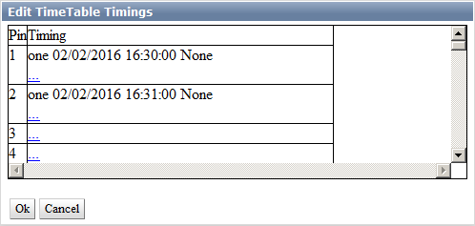 The “…” button opens the trigger settings for the selected Pin.
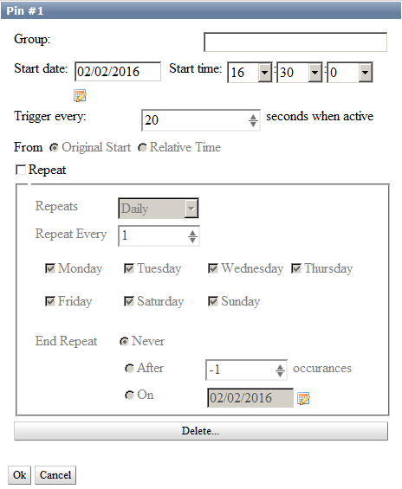
Parameter | Value
Group | Group for the selected Pin. If a group name is specified, the schedule item will stay active after triggering and continue generating events until another event from this group triggers. Contains an empty default value.
Start date
Start time
Trigger every (seconds when active) | Sets the interval of event re-generation in seconds. The parameter is active in the group mode.
From | Basic interval reference point for repeating the event. The parameter is active in the group mode.  - Original start - the interval start is the original start time of the event.  - Relative Time - the current time is set as the interval start.  The parameter sets the event processing option: for example, after a server restart.
Repeat
Repeats | Daily Weekly Monthly Yearly
Monday, Tuesday, Wednesday, Thursday, Friday, Saturday, Sunday
January, February, March, April, May, June, July, August, September, October, November, December
End Repeat | Condition for ending repetitions:  - Never - never end repetitions,  - After N occurrences - complete after N occurrences, where N is the number of repetitions.  - On DATE - complete on the specific date, where DATE is the end date.

Creating Action
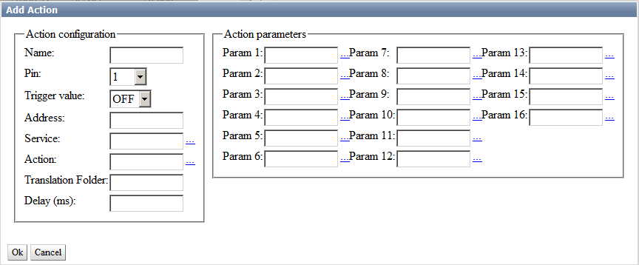

ADLink PCI-7250
Configuring GPI (ADLINK PCI/LPCI-7250 Board)
Not supplied with new servers.

ONTRACK ADU2x8
Configuring GPI (External USB Module ONTRAK)

HotKey
Configuring Server Management by Hotkeys or from External Control Panel

