SL NEO 7000 Slow Motion and Instant Replay Servers
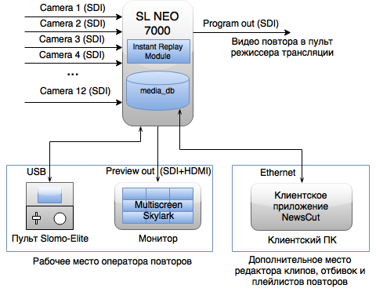

Basic Server Configuration
Add the Instant Replay component to the server configuration.

Basic Functions
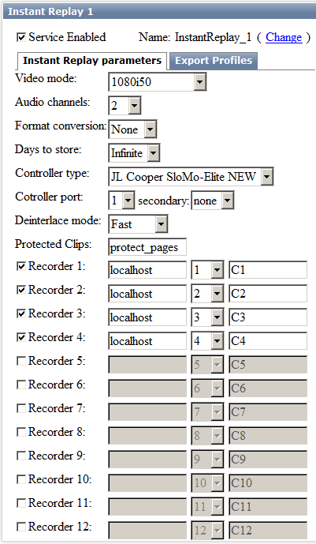
Option | Value
Video mode | Defines the output image format of the slow motion and instant replay server (the default value is 1080i50)
Audio channels | The number of audio channels (from 1 to 16, the default value is 2).
Format conversion | The option defines conversion for a PGM output of the replay server. The option behavior depends on the configured format of recording servers. The default value is none. More details...
Days to store | The option defines the number of days after which recordings will be deleted. Infinite - deleteion is not required, 1-30 - the number of days.
Controller type | - JL Cooper SloMo-Elite - a SloMo-Elite panel, in which switching cameras was implemented by buttons above the wheel. 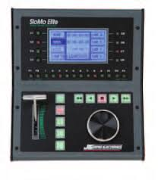  - JL Cooper SloMo-Elite NEW - this option must be selected, if the following panels are being connected:  - SloMo Elite-SM has physical buttons for switching 4 cameras above the T-bar, and the optical Jog/Shuttle  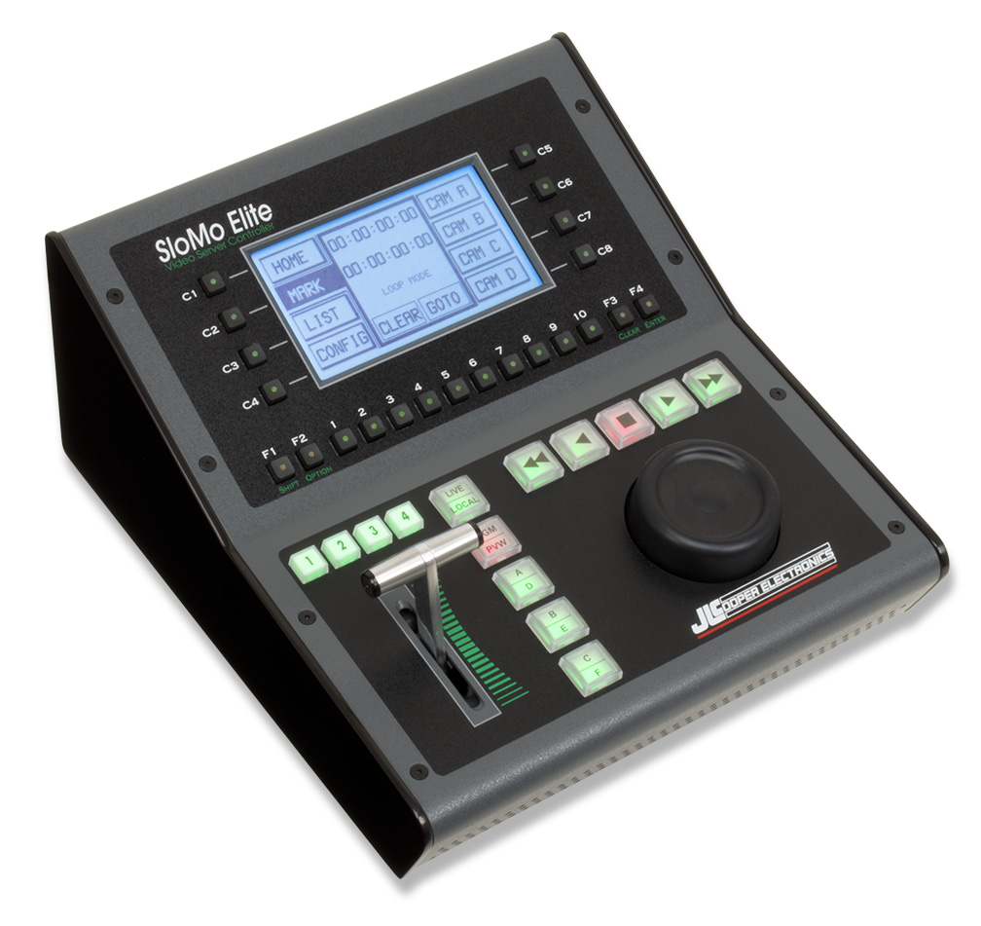  - SloMo Elite-C - a SloMo Elite-SM panel analogue reduced in size (c - compact). Support added in version 2.4.59.  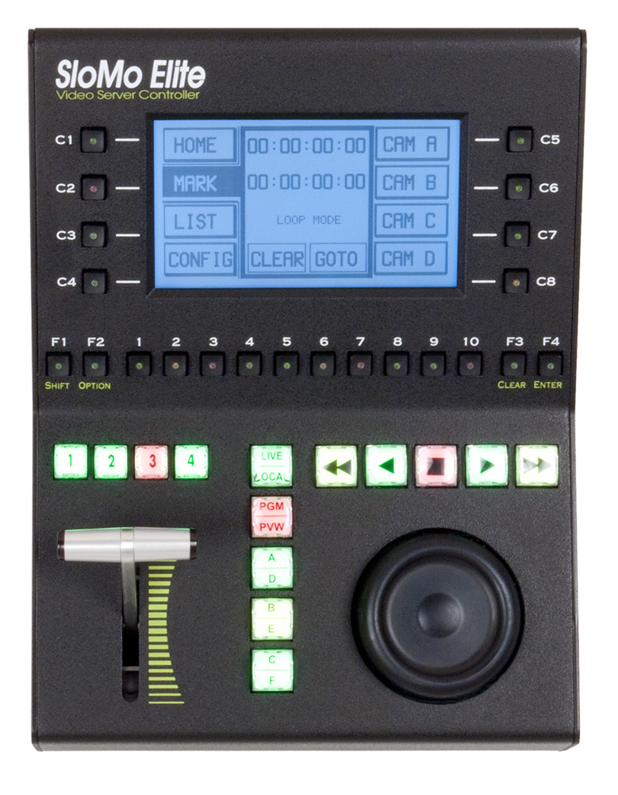 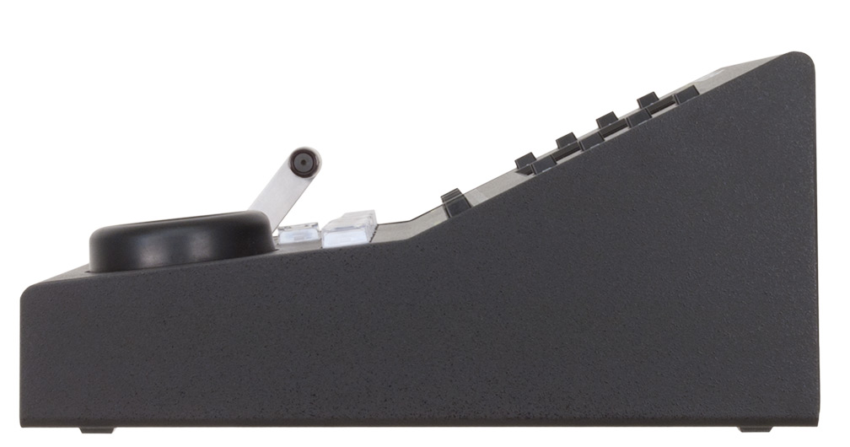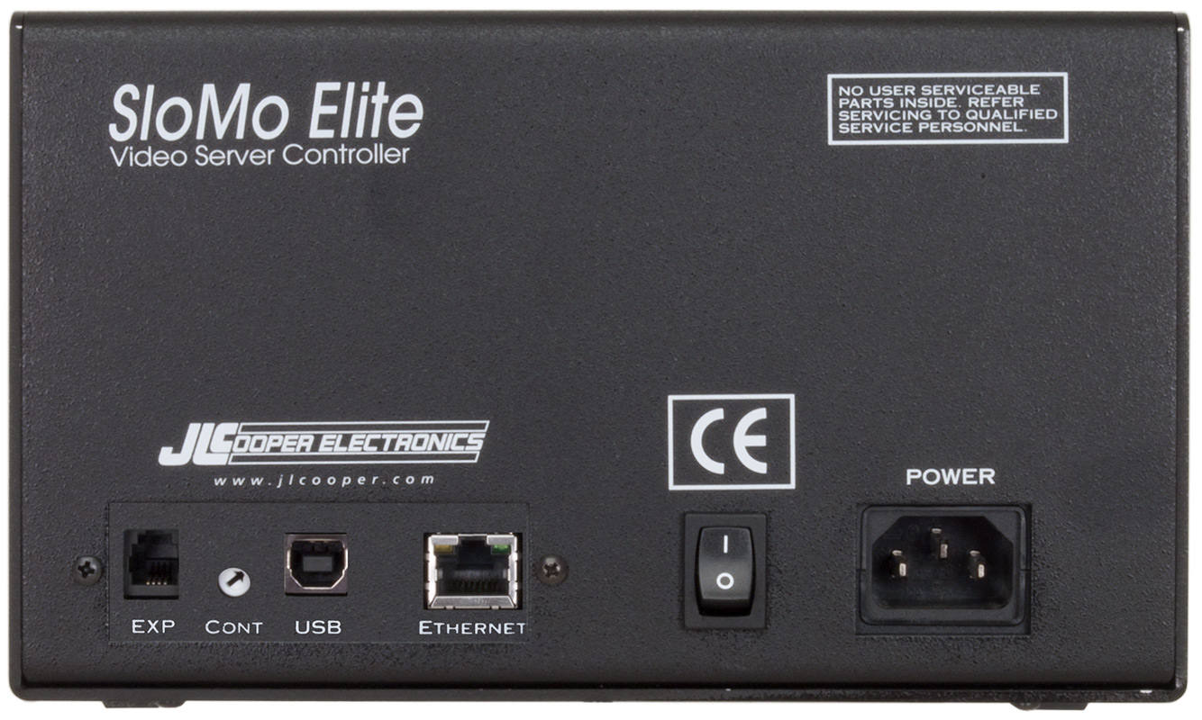
Controller port | Select the COM-port number.
secondary | Select the COM-port number while connecting another panel. Both panels will work simultaneously. The main one would be the panel that was launched earlier. The option was added for the possibility to organize two spaced-apart workplaces.
Deinterlace mode | Selecting an algorithm of building full frames for every image field during slow motion playback.  - Fast – better capacity  - Medium  - HQ – better picture
Protected Clips | The folder name in the database, to which the slow-motion and instant replay module will automatically render clips with Protected Pages.
Recorder 1-12 | - The checkbox of the recording channel activation.  - The recording server IP address (localhost).  - The number of the recording service at the server.  - The ingest channel name, displayed in multiscreen.

Export Profiles
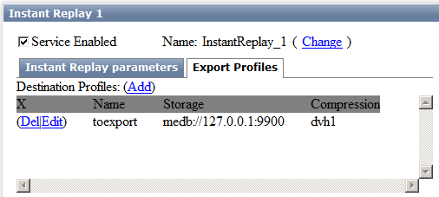
The tab allows configuring material profiles for panel export functions.

Symbols
“1” – one click: press and release the “1” button. [Shift, “1”] – consecutive pressing buttons: Press and release the first button, then the second one. [Shift + “1”] – simultaneous pressing buttons: Press and hold the first button, press the second button, release both buttons. Important! Pressing the button activates the action specified in the button lower section.
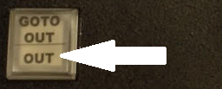
To implement the action specified in the button top part, first press and release Shift, then the button with the required action.
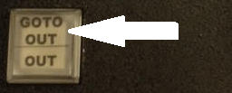
The slow motion and instant replay system has several inputs; their number and type depend on the server model. The system also has two outputs: the program output (PGM) and the Preview output (PVW).
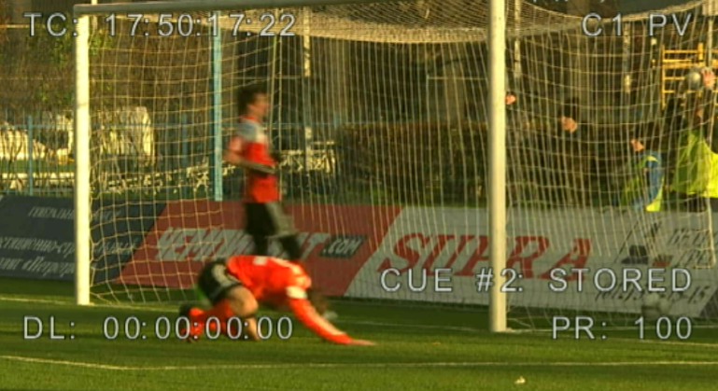
The program output serves for playback of prepared replays, and the Preview output serves for real-time viewing and preparing the replay. The Preview output may display the following additional information: TC – the current preview position time code in the HH:MM:SS:FF(*) format. Availability (or not) of the “*” symbol means an even or odd field, respectively. DL – the time difference between the current position and real time. TL – displaying the time left until the end of a clip or playlist. PR – the current playback speed, in percent. Сx – the selected camera, where x is the camera number. PV – indicates the activated Preview mode. Other information may also be displayed on the screen during work.

Recording Control
When using the slow motion and instant replay system, recording must be implemented uninterruptedly on all channels, during the whole sports event, simultaneously with playback of highlights and events editing. The number of recorded tracks corresponds the number of server inputs and depends on the server model.

Launching Recording
Enter the Option menu of the panel. Select the Start REC item; use the wheel to move between menu items. Press Enter. To exit the menu, press Clear.

Turning Off Recording
Enter the Option menu of the panel. Select the Stop REC item; use the wheel to move between menu items. Press Enter. To exit the menu, press Clear.

Recording Tray
The recording tray is the instrument for working with multi-track video. The tray allows users to navigate the recording, switch between tracks, implement playback with the regulated speed. The tray output always displays a signal from one of the cameras. The tray may be conditionally compared to the multi-track video recorder.

Panel
Managing all functions of the replay server is implemented with the professional control panel by JLCooper Electronics, included to the server delivery set.
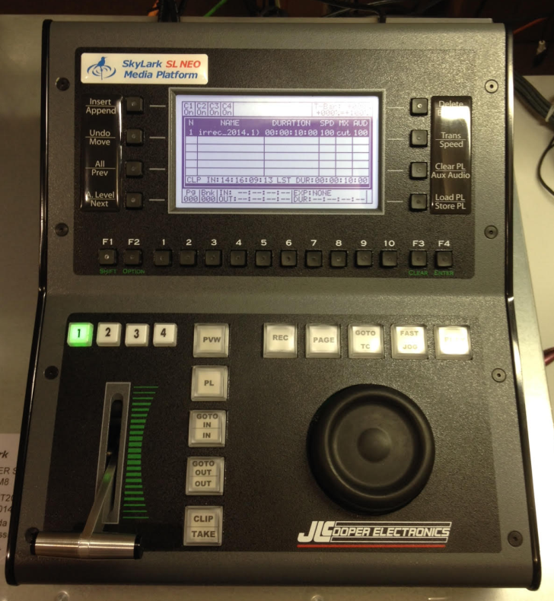

Panel Control Console

Switching Cameras/Recorded Videotracks:
Selecting cameras/tracks is implemented by the buttons for switching cameras. The “1”, “2”, “3”, “4” buttons go for 1-4 cameras/tracks. The selected button will blink with green. [Shift, “1”], [Shift, “2”], [Shift, “3”], [Shift, “4”] are 5-8 cameras/tracks. The selected button will blink with red. [Shift + “1”], [Shift + “2”], [Shift + “3”], [Shift + “4”] are 9-12 cameras/tracks. The selected button will blink with green/red. The number of recorded video tracks depends on the system model.

REC Button
Pressing the REC button switches the tray to the mode of working with Live video from cameras (The “LIVE” mode). The system in this mode works as a usual video switcher: buttons switch the live signal from cameras, not recorded video tracks. In the real-time mode, the REC button is red.

Wheel (Jog/Shuttle)
The wheel allows free surfing through the recorded video. Any wheel move switches the slow motion and instant replay system to the mode of work with the recorded material. The REC button fades, and the DL value at the Preview output of the system increases, displaying the difference between real time and the recording point, to which the video was rewound.

PLAY Button. Playback of Recorded Video
To start playback, press the PLAY button. During video playback, the buttons for switching cameras switch video tracks. All tracks recorded from cameras are played synchronously, that is why switching tracks during playback is similar to switching cameras at the video switcher. Playback speed will depend on the T-bar position.

T-Bar
By the T-bar you can adjust playback speed of the recorded fragment. The adjusting range of playback speed can be configured in the panel menu. The default value is 0-100%. Any move of the T-bar causes start of playback of the recorded video. If the bar is in its lowest position, and the adjusting range of playback speed is 0-100%, the system outputs a freeze frame.

IN and OUT Buttons
IN and OUT buttons define the fragment input and output points, setting the replay borders. IN and OUT buttons turn green. In the preview mode, IN and OUT points are defined by the image at the Preview output. Timecodes of IN/OUT points are displayed in the panel screen lower section. The GoTo IN and GoTo OUT buttons instantaneously rewind video to the IN or OUT point, respectively. You can delete the IN point by clicking the Clear button, and then the IN button. The OUT point is deleted similarly: Clear – OUT. After pressing Clear, IN and OUT buttons turn red. If you change your mind about deleting IN/OUT points, press Clear again.

Switching Memory Pages
To switch the page, press Page and the 1-10 digit. The current page number is displayed in the Pg section of the panel screen. The system provides 10 pages; each of them contains 10 banks.

Switching Memory Banks
To switch the bank, press Shift and the 1-10 digit. The current bank number is displayed in the Bnk section of the panel screen. Every bank contains 10 slots for saving.

Display Buttons
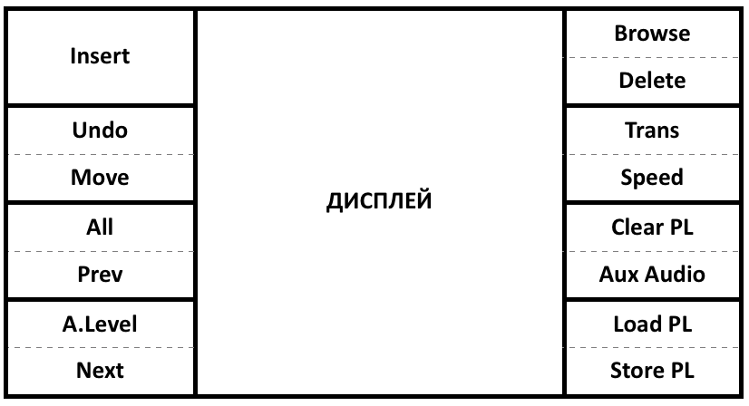

Panel Menu

Menu Access
Enter the menu: [Option] Exit the menu: [Clear] Switching values: To edit values of menu options, use the T-bar, wheel and number buttons, Enter button (depends on the edited value type).

Menu Items
- Export Clip – select the option for export. In case of adding several tasks, they are placed to the export queue, which is executed consequently.
  - Export Tray Clip – clip export from tray.
  - Export Playlist – export of the loaded playlist.
  - Export Playlist (Multicam) – export of the loaded playlist.
  - =======================
  - Cancel Current – cancels the current task in the queue.
  - Cancel All – cancels the task queue.
- =======================
- Start REC (the list of active recording services) - launches recording services.
- Stop REC (the list of active recording services) - stops recording services.
- =======================
- T-bar range (+000%-+100%, -100%-+100%, -200%-+200%) – sets the range of the T-bar playback speed.
- Shuttle speed (the value multiple of real time) - sets the speed of wheel rewinding in the Shuttle mode.
- Fast jog speed (the value multiple of real time) - sets the speed of wheel rewinding in the Jog mode with the pressed Fast Jog button.
- Audio (ON/OFF values) - turning on/off sound during replays.
- Def. Clip Dur (HH:MM:SS:FF timecode values) – sets the default clip timing (when IN/OUT points are not set).
- Set CUE on IN (ON/OFF values) – allows marking by pressing the IN button.
- Dissolve Dur. (0) –
- Take Swaps PVW (ON/OFF values) - swaps PGM and PVW windows . We recommend turning off this function by setting the OFF value.
- Rev Rec/Play (ON/OFF values) – swaps REC and PLAY buttons.
- JOG stops at (Fields/Frames values) – sets the type of wheel rewinding. Rewinding can be implemented by fields or frames.
- Rev Enter/Shift+Enter (ON/OFF values) – swaps actions set for the buttons (setting the marker ↔ adding a clip to the playlist).
- =======================
- Def. Playlist Mix Mode (vmix/xmix/over values) – sets the default transition type between playlists.
- Def. Playlist Mix Dur (frame values) – duration of mix-transitions between playlist elements.
- =======================
- Space Alarm (values in GB) – the operation threshold for the message about the lack of free space.
- Overwrite Clips (ON/OFF values) – allows overwriting clips.
- Display Delay (ON/OFF values) – turns on/off displaying the DL parameter on the screen.
- =======================
- Protected Pages… – opens the dialog for selecting protected pages (added in the 2.0.122 version).
  - Page 0-9 - setting protection for 0-9 pages (“Page 0” – 10 page, “Page 1” – 1 page, “Page 2” – 2 page etc).

Work Modes
The slow motion and instant replay system has three main work modes:
- Real-time mode - allows the operator to work with the recording tray for real-time playback of replays and setting markers for further usage.
- Preview mode - allows preparing new fragments for replays simultaneously with playback of the current replay.
- Playlist mode - allows the operator to compose, edit and launch playlists. For example, for creating a summary from interesting game moments.

1. Real-Time Mode
In this mode, all operator's actions are immediately displayed at the system program output; the same signal is sent to the program output and the Preview output (default mode).

How to implement a replay in the program mode:
– Wait for an interesting moment.
– Select the needed camera.
– Use the wheel to rewind to the start of the interesting moment.
– Report about the replay readiness.
– Press the Play button by the director's command.
– Adjust the speed of replay playback by the T-bar.

2. Preview Mode
In this mode, the operator can work with the Preview output, whereas the program output implements the replay. Switching cameras and rewinding will be displayed only at the Preview output. To launch the Preview mode, press the PVW button. The PVW button will turn red. In the Preview mode, switching tracks, wheel rewinding and switching to the LIVE mode are implemented only at the system Preview output. In the Preview mode, the T-bar controls playback speed only at the program output and does not affect video at the Preview output.
Important! Note that video at the program and Preview outputs may be from totally different moments of time.
The operator can find the needed position in the recording at the preview output and then send it to the program output with the Take button. Herewith, the video from the program output will be switched to the Preview output. (This option is set in the panel menu: the Swaps PVW” item to On. If the value is Off, images will not be swapped). To exit the Preview mode, press the Preview button again. After exiting the Preview mode, video from the program output is sent to the Preview output, the PVW button fades and all your actions will be displayed at both outputs simultaneously.

How to implement a replay in the Preview mode
The initial position: PVW and REC buttons are red. – Look at the Preview output.
– Use the wheel to rewind to the start of the interesting moment.
– Select the needed camera.
– Report about the replay readiness.
– Press the Take button: replay playback will start at the program output.
– Adjust the replay playback speed by the T-bar.
– Simultaneously to execution of the current replay, you may prepare a new fragment for replay at the Preview output. (or, which is easier, select another camera).
– See pt.4.

Clip Function
When using the Clip function, replays execution is implemented in the cycled mode, from the IN to OUT point. After reaching the Out point, playback returns to the In point. If the In point is not set, playback returns to the current point at the Preview output. To activate this function, press [Shift, Clip] buttons. The Clip button will turn green.

How to implement a fragment replay (series) with the Clip function
– Use the wheel to rewind to the end of the interesting moment.
– Press the Out button.
– Use the wheel to rewind to the start of the interesting moment.
– Press the In button (not necessary).
– Report about the replay readiness.
– Press the Take button: replay playback will start at the program output.
– Adjust the replay playback speed by the T-bar.
– Simultaneously to execution of the current replay, you may select a different camera at the Preview output. 10 seconds before the playback end, the Clip button will turn from green to red.
– After the current fragment replay, playback of a new fragment prepared in Preview will automatically start.

Rewind to Random Point by Time Code
For the transition to a random recording point by the time code, implement the following actions:
– Press the GoTo TC button.
– Enter the needed time code using panel number keys in the HH:MM:SS:FF format (hours, minutes, seconds, frames).
– Press Enter.
In the preview mode, transition to a random point by the time code is implemented only at the Preview output, not affecting the signal sent to the program output.

3. Playlist Mode
For transition to the mode of working with a playlist, press the PL button.

Adding Fragment to Playlist
To add the current fragment to the playlist end, press Enter. Adding fragments to the playlist is possible in any system work mode. To add a fragment to the selected playlist position, press Insert. If IN and OUT points are set (IN and OUT buttons are highlighted), the fragment limited with In and Out will be added; if IN and OUT points are not set, a 10 seconds fragment will be added (5 seconds before and 5 seconds after).

Fragment Deletion
To delete a selected playlist fragment, press Delete.

Playlist Navigation
- To move to the next playlist element, press Next.
- To move to the previous playlist element, press Prev.
- To move to the first playlist element, press PVW (only in the Playlist mode).
- To move to the last playlist element, press TAKE (only in the Playlist mode).

Moving Playlist Elements
– Choose the necessary element (Prev and Next buttons).
– Press the Move button.
– Use the wheel to move the element to the required position.
– Press Move to end moving.

Playlist Playback
Switch to the Playlist mode by the PL button highlighted with red. Video of the selected playlist element will be sent to the system output. To start playback, press Play or move the T-bar. The playback speed can be adjusted in real-time by the T-bar. The TL value showing the time left to the playlist end will appear at the Preview output.

Saving Playlist
The system may efficiently save up to 1000 playlists. To save a playlist to the bank at the current page, press the StorePL button, and the 1-10 digit – the playlist will be saved. Slots that already store saved playlists are highlighted with red. At the same time, CUTS-clips with names like irlist_#pbc appear in the database, where p is the page number, b – the bank number, c – the digit-button number. For example, irlist_#243.

Playlist Loading
Press the LoadPL button, then select a slot to load a playlist from. Slots that already store saved playlists are highlighted with green.

Playlist Deletion
Press the ClearPL button, then select a slot to delete a playlist from. Slots that already store saved playlists are highlighted with red.

Changing Clip Playback Speed in Playlist
- Select a playlist element.
- Press the Speed button.
- Adjust the speed with the T-bar.

Changing transitions
- Select a playlist element.
- Press [Shift, Trans].
- Use the wheel to set one of the transition effects (CUT, XMix, VMix, Overlay).
- Press Enter to save the changes.

Changing Sound Level During Clip Playback in Playlist
- Select a playlist element.
- Press the [Shift, A.Level] button.
- Adjust the level with the T-bar.
To simultaneously change parameters of clips in a playlist, use the function of selection. Activate the selection function by the [Shift, All] combination of keys, then implement the needed action with clips.

Cancelling Playlist Changes
Actions with the playlist may be cancelled. To cancel an action, press [Shift, Undo] one or several times, until you reach the needed result.

Playlist Export
- Enter the Option menu.
- Select Export.
- Select Export Playlist.
- Select the profile, it may be configured in Administrator Control Panel – Manage – Instant Replays – Export Profiles.

Fragments

Saving Fragments
The system may efficiently save up to 1000 clips. To save a clip to the bank from the current page, press the 1-10 digit – the clip will be saved, the digit button will be highlighted with red. Herewith, clips with names like irplay_#pbc-{k} appear in the server database, where p is the page number, b – bank number, c – digit-button number, and k – video track number.
If the selected slot already contains a saved clip, the panel screen will display the message. To overwrite the slot, press Enter.

Loading Fragments
To load the needed fragment, select the slot (page and bank). The number button will be highlighted red, if the current slot already contains a saved clip. After pressing the number button, the clip will be loaded to tray and the button will turn green.

Editing Fragments
If a slot clip is loaded to tray (the number button is green), you can edit its IN and OUT points. Use the wheel to change the position and press the IN or OUT button; the fragment will be updated.

Fragment Export
- Enter the [Option] menu.
- Select Export.
- Select Export Tray Clip.
- Select the profile, it may be configured in Administrator Control Panel – Manage – Instant Replays – Export Profiles.

Protection of Memory Pages
Memory pages can be protected from erasing. Enter the panel menu (see above), select the Protected Pages… item. Mark the pages, for which the Clear Page function will not be called (Page 0 – 10th page, Page 1 – 1st page, Page 2 – 2nd page etc).

Erasing Clips from Current Page
The Clear Page function deletes all clips from all banks of the current page. The function is called by the Clear (F3) button, and then Page (added in the 2.0.122 version).

Automatic Rendering Clips from “Protect Pages”
In the 2.0.123 version, the function of automatic rendering clips from “Protected Pages” has been added, to separate files in the folder configured in the web-console:
Administrator Control Panel→Manage→Instant Replays→Instant Replay_N→Instant Replay parameters→Protected Clips
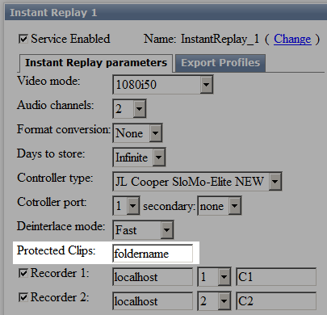
Herewith, clips with names like irplay_#pbc-{k} appear in the server media base, where p is the page number, b – bank number, c – digit-button number, and k – the video track number.

Markers (Key Frames)

Setting Markers
To set a marker in the current position, press [Shift+Enter].

Markers Navigation
- To the first one in recording – [Shift+1].
- To the next one – [Shift+Clear].
- To the previous one – [Shift+Option].
- To the last one in recording – [Shift+10].

Multi-Cam Clips
A Multi-cam clip allows selecting a camera during its playback. All clips in the database will be considered multi-cam, if their mediaid satisfies the following format: name-{k}, where “name” is the random clip name, k – the video track (camera) number.

Integration with NewsCut
Recordings of all tracks are available for viewing and using in the Skylark database right after the start of recording, in the irrec_YYYY_MM_DD folder. Fragments saved to slots are also available in the database. You can create a new NewsCut project, promptly use video recordings and saved fragments for editing, simultaneously to the system work. Playlists are available in the database as CUTS-clips. If you right-click on the corresponding CUTS-clip and select the Edit item, the CUTS-clip will be loaded as the NewsCut project. After editing, the CUTS-clip can be saved again: File→Save Clip. Important: replay system playlists operate only one video track.

Slowmotion API
Example of Replay Server Management from JavaScript via Instant Replay API

