SL NEO Software Installation
Also see the article Skylark Software Updating Order.

Possible Problems

Compatibility Problem
During the installation of Skylark software you receive the message “This program might not have installed correctly”.
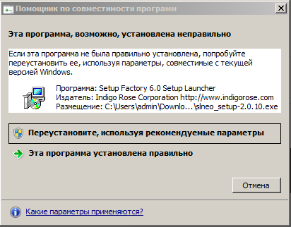
Select the “Install using recommended parameters” item.

Saving Settings Problem
If in client applications settings are reset after exit, configure launching as an administrator. Right-click the application shortcut, select Properties.


