Support of SRT Protocol
Secure Reliable Transport (SRT) - the UDP-based protocol for data transfer, optimised for transfer through the Internet. The protocol has the error-correcting mechanism, decreasing the data loss in case of unstable connections. SRT is used for receiving and sending data, providing the best quality and the lowest latency.
SRT support was added in the version 2.6.26 for the Eazymuxer app - the module for capture and output of MPEG TS streams.

Description
SL NEO supports three SRT connection modes: Caller, Listener, and Rendezvous. Note that the mode defines the connection initiator, but not the direction of MPEG TS transfer. Selecting the mode of network connection initiation is defined by the network environment and the necessity of configuring the network screens.
- Caller - the service initiates the outbound connection with the remote machine. Sometimes this type of connection is called Client.
- Listener - the service is waiting for the incoming connection. Sometimes this type of connection is called Server.
- Rendezvous - in this mode, both units initiate connection. The mode is used, when both units are behind firewalls, allowing for connection without configuring the firewall.
Example:
Client А | Client Б | Description
Playout  (SRT Caller) | Capture  (SRT Listener) | Client A connects to Client B, who is waiting for incoming connections. Client A sends the stream, and Client B receives it.
Playout  (SRT Listener) | Capture  (SRT Caller) | Client B connects to Client A, who is waiting for incoming connections. Client A sends the stream, and Client B receives it.
Playout  (SRT Rendezvous) | Capture  (SRT Rendezvous) | Both clients establish the connection, then Client A sends the stream, and Client B receives it.

Configuring IP Capture and IP Playout
Work with the SRT stream requires adding a new IP Capture or IP Playout service to the menu: Administrator Control Panel→Manage→Video IO Boards→LAN Interfaces/Ethernet Adapter→Add Service.
The created service must have the Video Input/Video Output = MPEG2TS/IP mode specified on the tab: Administrator Control Panel→Manage→Video IO Boards→LAN Interfaces/Ethernet Adapter→Capture/Playout→General.
The order of configuring the output bitrate, video mode, encoding parameters for video/audio, and other parameters of the output stream are described here.
The options of configuring the SRT stream for IP Capture are located on the tab: Administrator Control Panel→Manage→Video IO Boards→LAN Interfaces/Ethernet Adapter→Capture→IP Parameters
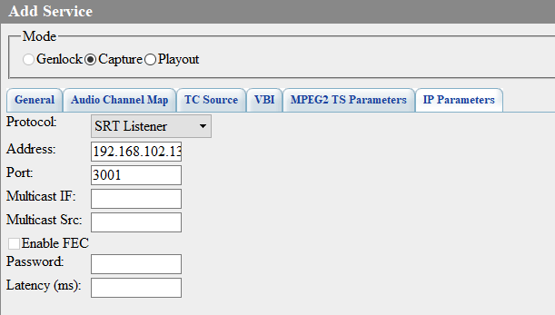
The options of configuring the SRT stream for IP Playout are located on the tab: Administrator Control Panel→Manage→Video IO Boards→LAN Interfaces/Ethernet Adapter→Playout→IP Parameters
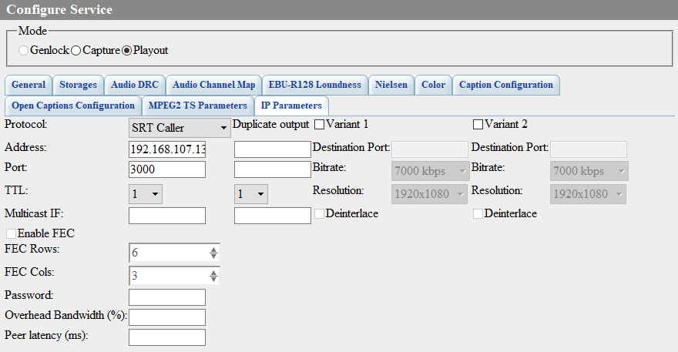
Parameter | Description
Protocol | Select the protocol. Three modes described above are available for working with the SRT protocol:  - SRT Caller,  - SRT Listener,  - SRT Rendezvous.
Address | IP address. The address is specified depending on the mode selected in the Protocol window. For instance, specify the external address of the remote receiving device for the SRT Caller mode.
Port | In this field, specify the remote port for the outbound connection (Protocol=SRT Caller or SRT Rendezvous) or a local port for listening (Protocol=SRT Listener).
Password | Entering the password. Specifying the password at the sending side automatically activates the encryption mode for the transferred stream. The minimum password length is 10 symbols. If the number of symbols is less than that, encryption will not be activated. Specifying the password at the receiving side is necessary for retrieving the encrypted stream.
Overhead Bandwidth (%) (only in the Playout service) | Overhead Bandwidth defines the bandwidth size in percent to be used for resending lost data and provide uninterrupted broadcasting. The maximum amount of time during which packets may be lost with no artifacts on the transferred image is calculated by the formula: Latency (ms) * Overhead (%) ÷ 100
Latency (ms) | The Latency value may be from 20 to 8000 ms, which defines the maximum size of the buffer available for management of SRT packets. The Latency parameter may be set both at the sending device and the receiving one. The higher value will be used for the SRT stream. The SRT source device buffer contains sent but unconfirmed packets (their retrieving was not confirmed by the receiver) The SRT destination device buffer contains received stream packets that are waiting for decoding. The Latency value must allow the source buffer content (in ms) on average to stay below, and the receiving device buffer to never go down to zero. If the number of lost packets is slowly increasing, it is recommended to increase the SRT latency value. If it's increasing rapidly, it is better to decrease the video bitrate or increase Overhead Bandwidth.

Download
- Detailed Description of SRT Protocol (SRT Alliance)

