Alert Function Based on Displayed Signal Analysis
The description is valid for software version 2.11.0 and newer.
The Multiscreen module allows to configure visualization of alerts over the signal image in the window, where the video and audio signal problem detector was triggered. Based on the analysis results, alerts are generated and used:
- to trigger Events,
- for sending email,
- for functions (Failover Switchers).

Supported Alerts List
- Video Frozen - a freeze frame has been detected,
- Video Black - a black field is detected,
- Audio Silence - silence is detected,
- Audio Overload - audio overload is detected.
- No Signal - no signal is detected. This alarm has no additional settings and is always on. This alert is triggered when the “SIGNAL NOT PRESENT” auxiliary packet is detected, which is added by the Capture module at the moment of signal cutoff. This alert differs from “Video Frozen”/“Video Black” in that “No Signal” does not require video processing and because of this it uses less computational resources. The “No Signal” alert is also issued for windows that use NVT streams from remote servers when the stream cannot be opened. Thus, the alert will be issued when the remote server is not operating or is unavailable. Added in version 2.11.0.

Function Operation Example
Alert examples:
Abbreviated alerts | 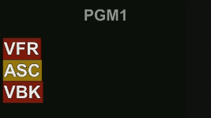
Full alerts | 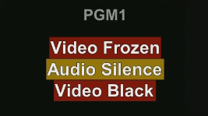

Configuring
Configuring alerts based on the analysis of the displayed signal is done for each editable window individually: Administrator Control Panel→Manage→Multiscreen→Multiscreen_N→Layout→Layout→Edit→Alarms.
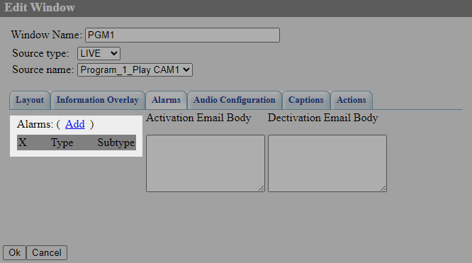
The Add button opens the alerts configuration dialog.

Alert Configuration Dialog
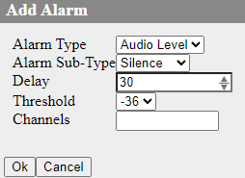
Parameter | Description
Alarm Type and Alarm Sub-Type | Options define the type of alert:  - Still Detect - alerts for image,  - Still - a freeze frame detection,  - Black - a black field detection,  - Audio Level - alerts for audio,  - Silence - silence detection,  - Overload - overload detection.
Delay | Set the delay before the alarm is triggered.
Threshold | The setting depends on the type of alarm:  - For Audio Level - sets the alarm threshold in dB.  - For Still Detect - sets the sensitivity of triggering of frame match detection. If Threshold is about 0, even small changes in the frame will be detected as the presence of motion. If Threshold is large, even significant changes in the frame will be ignored.
Channels | For audio silence and audio overload alerts, you can list the channel groups to be used for monitoring. An empty value is used to monitor all channels. Channel groups are separated by a comma. For example, 1-2,3-4 will make 2 groups of 2 channels each.  - Audio silence will be triggered if there is silence in at least one group.  - Audio overload will be triggered if there is overload in at least one group.  Added in version 2.10.48.

